Vinyl Crash Rail
Models: CRVS4C, CRVE4C, CRVS6C, CRVE6C,
CRVS8C, CRVE8C,
CRVS5C, CRVE5C, CRVS7C and CRVE7C

Important Notes:

- Locate and install Crash Rail in accordance with architectural drawings and specifications. When required, shop drawings should be used in conjunction with these documents
- Locate the packing slip(s) and inspect all material for damages or missing parts. If products are damaged, notify the factory immediately and leave the products in their packaging. If products are signed and received without reporting damages, you waive your right to a freight claim and will be responsible for their replacement cost.
- Store material in a clean, dry location at room temperature between 65° F (18° C) and 77° F (25° C) for at least 24 hours prior cutting and installing to minimize expansion and contraction of materials.
- Read the instructions thoroughly before beginning installation.

Vinyl Crash Rails

- Lay out the work to be completed, including all component parts, along the base of the wall. Check the material for any damage that may have occurred during shipment and/or handling at the job site.
- Snap a chalk line at the proper location on the wall to ensure a level installation. Chalk line should be calculated to the center line of the mounting bracket wall fasteners.
- Place the retainer in the proper position on the chalk line and mark hole locations using the proper bit size for fasteners.
Note: All crash rail and handrail material is provided in 20’-0” stock lengths to be cut in the field. A 80-100 tooth, carbide tip saw blade or equivalent is recommended for cutting the material to minimize chipping.
The aluminum retainer has been supplied in stock lengths, it will be necessary for it to be field-cut. Determine the allowances necessary for door jambs, corner conditions, etc. (See back) and cut retainer to proper length. Drill proper size holes at center of retainer 3" (76.2mm) in from each end and all intermediate locations not to exceed 32" (812.8mm) O.C.
- Attach connector plates to ends of retainer using 1" (25.4mm) pan head screws.
- Attach ends and corners with washer and machine nuts as required.
- Attach splice joints with #10 x 1-1/2" (38.1mm) machine screws, washers, and nuts.
- Mount assembly to wall using proper fasteners (not included). Tighten securely.
Note: Prior to installation of the cover, make sure that all fasteners are secure and properly seated.
- Hold the cover at an angle and place the top of the cover behind the top of the retainer. Make sure that the cover is placed in the proper position and snap-fit the cover onto the aluminum retainer by placing hands downward and applying pressure with the heel of each hand to force the cover onto the retainer. Continue along until the complete length of the cover is securely installed.
- If you have any questions during installation, please contact Nystrom.
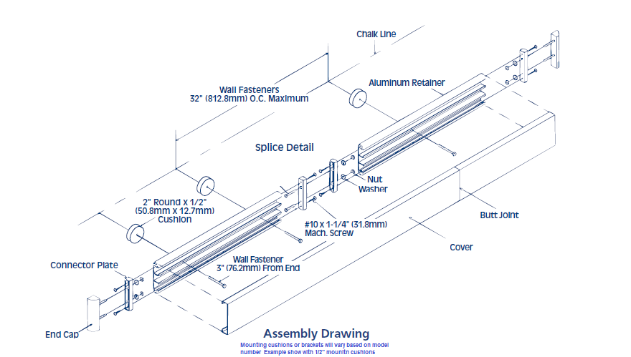

Installation Dimensions for CRVS4C, CRVS4C-C125 (1/8” mounting cushion), CRVS4C-C05 (1/2” mounting cushion), CRVE4C-B15 (1 ½’” mounting bracket) and CRVE4C-B2 (2” mounting bracket).
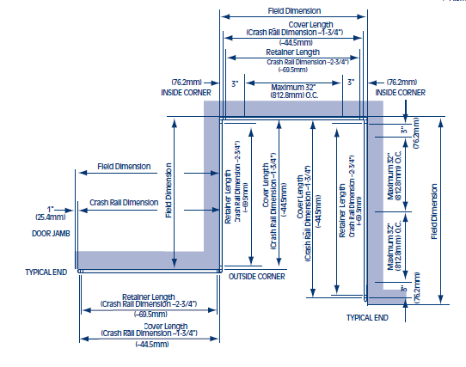
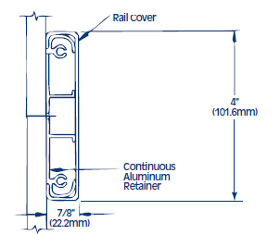 | 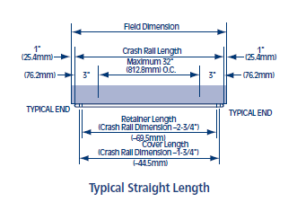 | 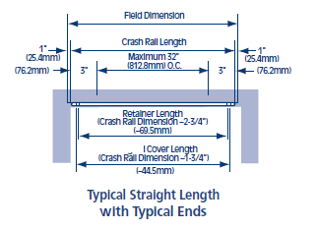

Installation Dimensions for CRVS6C, CRVS6C-C125 (1/8” mounting cushion), CRVS6C-C05 (1/2” mounting cushion), CRVE6C-B15 (1 ½’” mounting bracket) and CRVE6C-B2 (2” mounting bracket)

Installation Dimensions for CRVS8C, CRVS8C-C125 (1/8” mounting cushion), CRVS8C-C05 (1/2” mounting cushion), CRVE8C-B15 (1 ½’” mounting bracket) and CRVE8C-B2 (2” mounting bracket)
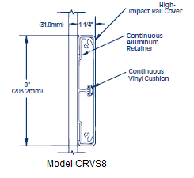

Installation Dimensions for CRVS5C, CRVS5C-C125 (1/8” mounting cushion), CRVS5C-C05 (1/2” mounting cushion), CRVE5C-B15 (1 ½’” mounting bracket) and CRVE5C-B2 (2” mounting bracket).

Installation Dimensions for CRVS7C, CRVS7C-C125 (1/8” mounting cushion), CRVS7C-C05 (1/2” mounting cushion), CRVE7C-B15 (1 ½’” mounting bracket) and CRVE7C-B2 (2” mounting bracket).

Maintenance:
- Use mild detergent to clean soiled surfaces. Do not use powdered cleansers, bleach and ammonia-based cleaners as they may leave a residue embedded in the cover surface. Pen marks, paint and graffiti generally wash off easily with mild soap and water. Completely rinse the surface with clean water when complete.
- Tough marks or stains may require a heavy duty cleaner such as “Crown Anti-Vandal Spray” or “DWR-II”. These specialized spot cleaners should only be used on small areas and tested for color fastness prior to applying in a highly visible area. Rinse thoroughly with clean water to remove the residue from these cleaners

