September 1, 2015
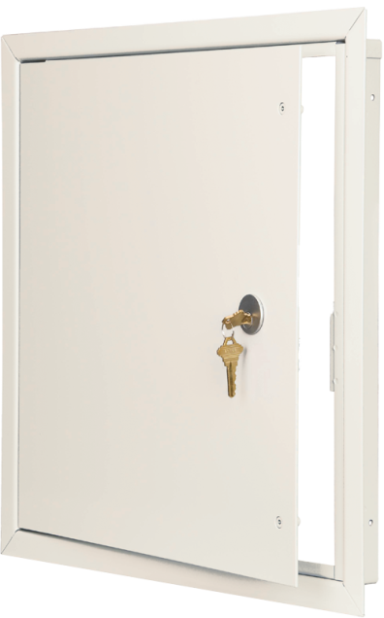
RE: Standard Powder Coat Color Change
In response to market demand, Nystrom announces a shift from gray to white doors. Nystrom Access Doors will maintain the same features and quality, but will now have white powder coat paint with a lower sheen finish. The white paint will allow for less time in the field when secondary painting is required. Expect to start seeing these arrive towards the end of the year.
- Warehouse inventory will be turned over to white as orders are processed.
- For a period of time, orders will ship with a mix of gray and white.
- Please indicate at time of order if all one color is required.
- Orders for gray placed after January 1, 2016 will be custom.
For additional questions or concerns, please contact your customer service rep. We appreciate the opportunity to service you.
Dalen DeFoe
Product Manager

