Model(s): F-1, F-3, F-7, F-8, F-11, F-13
Prepare for Installation
- Locate the packing slip(s) and shop drawings.
- Verify that all products listed on the packing slip are included in the package.
- Check the products for damage. If products are damaged, report a freight claim immediately and leave the products in their packaging. If you sign for products without reporting damage you waive your right to a freight claim and will be responsible for their replacement cost.
- Read the instructions thoroughly before beginning installation.
Install the Frame
A flat recess and accurately installed frames are critical to the overall performance of the mat / grille. Utilize a self-leveling compound (provide by others) if necessary to ensure a level recess,
- The rough opening for the frame should be at least the depth of the frame and 6 inches wider and longer than the frame. This allows room to maneuver the frame and provides clearance for the anchor bolts.
- Insert the 1/4 inch by 3 inches anchor bolts and nuts in the frame channels. The anchor bolts should be spaced at a maximum distance of 24 inches on all sides of the frame.
- 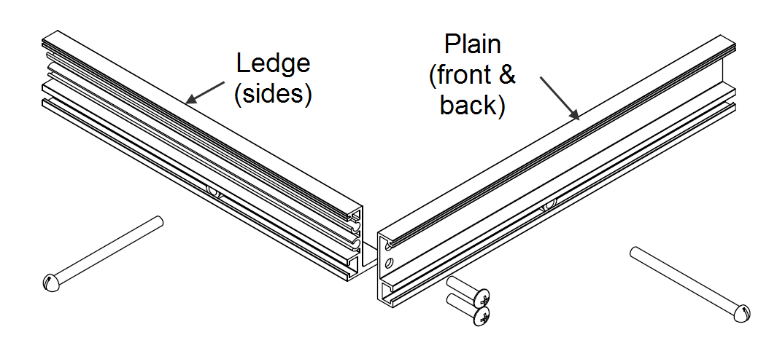Assemble the frame sections according to the shop drawings. Note that there are two types of frames: ledge (sides) and plain (front and back.) The ledge pieces can serve as a screed for leveling the concrete. If frames lengths are provided in sections, splice bolts are provided for connecting pieces together. Insert the 1/4-20 by 1 inch self-threading screws through the pre-punched holes in the plain sections of the frame and into the screw bosses on the ledge sections without tightening them completely. When the frame is completely assembled, finish tightening all screws.
- Place the assembled frame into the opening. Shim as necessary to level the frame to the final height of the finished floor surface.
- Pour cement mortar around the edges of the frame and the center in sufficient quantity to be level with the inside lip of the frame.
- With a board that is slightly shorter than the inside of the frame, smooth and level the mortar. It is critical that the recess be flat within 1/8 inch over 10 feet and at the correct height to prevent damage to the product.
- Before the mortar sets, check the frame to make sure that it is plumb, that the members join at the correct angles, and that it is at the correct height. Also, check the measurements of the frame against the shop drawings in several locations to make sure that the sizes are correct. The mat / grille will not fit if the frame is not installed exactly as indicated on the shop drawings. Use spreaders if necessary to hold the frame at the correct dimensions.
- After the mortar has set, lay the optional drain pan material (if applicable) in the bottom of the recess. Caulk all edges and seams.
- When the cement has hardened, install plywood or other material in the recess to protect the edges of the frame until it is time to install the grilles. Wait to install the mats / grilles until the building is ready for use.
Install the Grille
- Remove the plywood or other filler from the recess and clean the recess thoroughly. Note that debris will cause irregularities in the recess that may cause the grille to rock or create a tripping hazard.
- Consult drawings to determine the correct locations of the grille sections. Note that grilles must be in the proper location, with all sections facing the same direction. The triangular keylock holes will all point the same direction when installed properly.
- Move the cushions to the outer edges of each section and spaced at a maximum distance of 24” on the rails.
- Set grilles into the recess.
- Adjust cushions to compensate for slight irregularities in the recess.
- Save the installation and maintenance instructions and include them with the closeout documentation for the owner and maintenance personnel.
Install the Mat
- Remove the plywood or other filler from the recess and clean the recess thoroughly. Note that debris will cause irregularities in the recess that may cause the mat to rock or create a tripping hazard.
- Consult drawings to determine the correct locations of the mat sections. Mats provided in multiple sections in the traffic direction will include an additional hinge for combining the sections.
- Unroll the mat inside the frame. Push the mat tightly up against one side of the frame. Trim the attached vinyl filler to ensure a tight fit in the recess.
- Save the installation and maintenance instructions and include them with the information that will be passed on to the owner or maintenance personnel.
Maintenance
Continued maintenance is critical to the long-term safety and performance of the mat / grille. Remove the mat / grille and clean the recess periodically to prevent the surface from becoming uneven. Debris build up within the recess could lead to deflection in the grille and may possibly cause tripping hazards.
The type and schedule of maintenance of your grille or mat will depend upon location and amount of traffic. See the outline below for cleaning instructions for the variety of tread insert materials.
Aluminum Abrasive
- Clean the vinyl abrasive treads with a vacuum or broom.
- Do not use any hydrocarbon solvents such as kerosene, paint thinner or acetone to clean aluminum abrasive treads. These types of solvents will damage the treads
Premium Carpet, EnvIRONtread II®
- A good heavy-duty vacuum cleaner with a rotating brush is the most effective way to routinely clean the carpet in your entrance grille or mat. By vibrating the fibers, this type of vacuum not only cleans the surface of the carpet, but also removes soil that is imbedded into the pile. The rotating brush aids in keeping the pile upright for longer lasting beauty.
- The heaviest traffic areas should be vacuumed daily and the light traffic areas as infrequently as weekly.
- Carpet should be deep cleaned with a hot water extraction cleaner once per month or when vacuuming will no longer remove the soil. This may be monthly, quarterly, or longer, depending upon soil and traffic conditions.
- Inspect the grille or mat regularly for spots and stains, to reduce the possibility of them becoming permanent.
- Removing Spots
  - If the spot is semi-solid, scrape with a spoon or spatula and then blot with a damp sponge. Work from the edge of the spot to the center. This will keep the stain from spreading. If this
procedure does not work, use a spot remover.
  - We recommend a dry system because it reduces solid build-up won’t leave floors wet and slippery, and there is no risk in damaging the carpet from dye bleeding. For most spills such as coffee, tea, pet stains, etc., a dry soil extractor works best.
  - Wet cleaning methods, including aerosols, foams, hot water extraction, or shampoo will work, but sometimes they leave sticky detergent residue that will accelerate soil build-up.
  - For oily stains such as tar, grease, paint, etc., a non-flammable dry cleaning solvent works best. Be extremely careful when using dry cleaning solvent. Take care to check for color fastness before cleaning the entire surface. Put a few drops of stain remover in an inconspicuous area and press the area with a clean cloth for ten seconds. If the color fades or changes, discontinue use.
Rubber
- Use a mild detergent and water to damp mop the rubber treads. To remove caked on mud, use a stiff brush.
- Do not use petroleum-based products to clean rubber. These types of solvents will damage or fade the treads.
Rugged Scrub®
- The most effective way to clean the treads is with a garden hose or high-pressure washer, as necessary. The treads can withstand pressure of up to 1,000 pounds per square inch. A good heavy-duty vacuum cleaner with a rotating brush will remove most dirt from your Rugged Scrub® treads during routine daily cleaning.
- Do not use petroleum-based products to clean Rugged Scrub. These types of solvents will damage or dissolve the treads.
Serrated Aluminum Mats and Serrated Aluminum Thin Line and Waffle Grilles
- Clean the treads with a vacuum or broom first, and then mop the treads with standard floor cleaner.
Stainless Steel Grilles
- Surface wires can be cleaned with a non-ferrous cleaner such as 3M’s Scotch Brite™
- Do not use steel wool or abrasive pads. The steel in these products will embed in the wires and
subsequently rust.
Vinyl Abrasive Tread
- Clean the vinyl abrasive treads with a vacuum or broom.
- Do not use any hydrocarbon solvents such as kerosene, paint thinner or acetone to clean vinyl abrasive treads. These types of solvents will damage or fade the treads.
Vinyl Tread
- Use a mild detergent and water to damp mop the vinyl treads. To remove caked on mud, use a stiff brush.
- Do not use petroleum-based products to clean vinyl. These types of solvents will damage or fade the treads.
Follow the tread maintenance instructions to ensure the long life of the grille tread. Contact Nystrom for information on replacing damaged treads.

