Vinyl Surface Mount Corner Guard
Models: CGVS2S, CGVS3S

- Apply and secure a bottom cap beginning directly above cove base with appropriate fasteners.  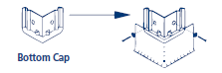 | - Apply continuous retainer to wall directly above bottom cap with appropriate fasteners at 18"(457.2mm) O.C  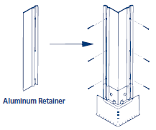 | - Install top cap directly above aluminum retainer  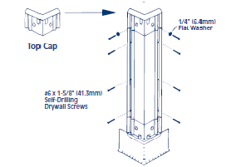
- Snap precut cover in position. Cover should be lipped over one edge and pressure applied toward opposite leg from center with a “snap action” movement. Procedure should begin at bottom and be repeated as necessary for full height of cover.  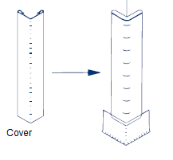 | - Contact your Nystrom representative for information on replacement parts | 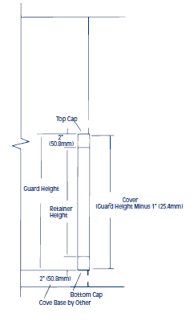

Maintenance:
- Use mild detergent to clean soiled surfaces. Pen marks, paint and graffiti generally wash off easily with mild soap and water. Completely rinse the surface with clean water when complete.
Note: Powdered cleansers and bleach cleaners should be used with care as they may leave a residue embedded in the cover surface. Properly rinsing with clean water will remove any residual residue.
- Tough marks or stains may require a heavy duty cleaner such as “Crown Anti-Vandal Spray” or “DWR-II”. These specialized spot cleaners should only be used on small areas and tested for color fastness prior to applying in a highly visible area. Rinse thoroughly with clean water to remove the residue from these cleaners

