Extended Mount, Aluminum Crash Rail
Models: CRAE4
Important Notes:

- Locate the packing slip(s) and inspect all material for damages or missing parts. If products are damaged, notify the factory immediately and leave the products in their packaging. If products are signed and received without reporting damages, you waive your right to a freight claim and will be responsible for their replacement cost.
- Begin installation only after finish construction has been completed and building interior has been within temperature range intended for continued use for at least 24 hours.
- Read the instructions thoroughly before beginning installation.
- Aluminum Extended Mount Crash Rails are provided in 10 feet lengths to be field cut and installed. Cut r aluminum components to fit only after they have been at temperature intended for continued use for 24 hours.
- Carefully measure and mark all holes to be drilled to achieve a properly supported and level installation.

Measure

- Measure and mark centerline of rail brackets on wall or partition. This height is obtaining by subtracting 2” (50.8mm) from desired height of top of rail.
- Measure and mark location of the ends or returns, corners and joints between abutting length, if any, on wall or partition centerline (see Standard Plan Details). These marks will also indicate the location of rail-end mounting bracket fasteners.
- Measure and mark intermediate mounting bracket fastener locations on wall or partition. Mounting brackets are required at least ever 32” (812.8mm) O.C. max.
- Drill mounting bracket fastener holes at locations marked.
- Install mounting brackets at end return and corner conditions. For most drywall applications, we recommend ¼” – 20 round head bolts and ¼” size toggle bolts. For most masonry applications we recommend ¼” lag screws and plastic anchors.
- Mount end returns and corner accessories
- Measure and cut rail sections to length as required.
- Drill and countersink rail sections for 1/4" - 20 attachment screws, using an 9/32" drill and an 82° countersink. Drill one hole on each end of rail section, and two holes for intermediate mounting brackets using layout dimensions shown. Use care to avoid countersinking holes too deep.
- Clean rail and brackets after installation.

Maintenance:

- Use mild detergent to clean soiled surfaces. Pen marks, paint and graffiti generally wash off easily with mild soap and water. Completely rinse the surface with clean water when complete.
Note: Powdered cleansers and bleach cleaners should be used with care as they may leave a residue embedded in the cover surface. Properly rinsing with clean water will remove any residual residue.
- Tough marks or stains may require a heavy duty cleaner such as “Crown Anti-Vandal Spray” or “DWR-II”. These specialized spot cleaners should only be used on small areas and tested for color fastness prior to applying in a highly visible area. Rinse thoroughly with clean water to remove the residue from these cleaners.

Assembly Drawings
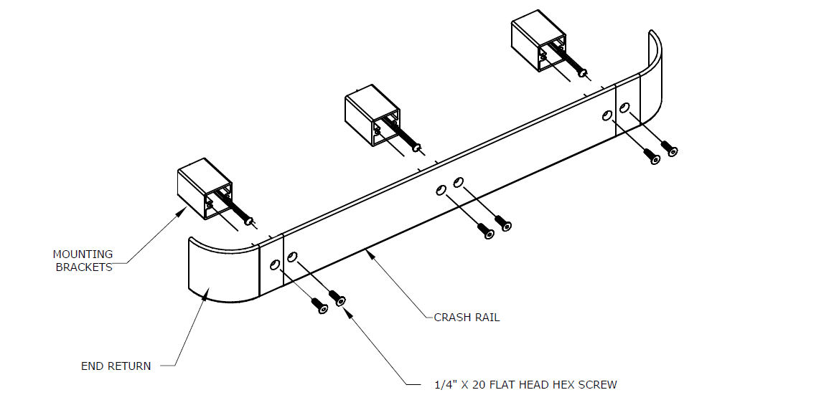
Model  CRAE4-BS |  | Returns and Corners pre-cut and drilled for field installation  End Cap: CRAE4-BS-EC  Outside Corner: CRAE4-BS-OC  Inside Corner: CRAE4-BS- IC
Model  CRAE4-BI2 |  | Returns and Corners pre-cut and drilled for field installation  End Cap: CRAE4-BI2-EC  Outside Corner: CRAE4-BI2-OC  Inside Corner: CRAE4-BI2-IC
Model  CRAE4-BI3 |  | Returns and Corners pre-cut and drilled for field installation  End Cap: CRAE4-BI3-EC  Outside Corner: CRAE4-BI3-OC  Inside Corner: CRAE4-BI3-IC

