Safe-T-Lume™ Handrail Strip
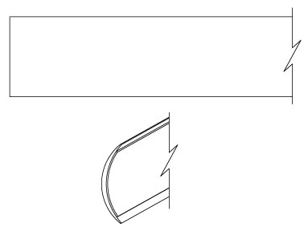
INSTALLATION, OPERATION + MAINTENANCE MANUAL
Model(s): EM-DSH1

Table of Contents

Table of Contents
General Description 3
Installation 4
Operation 5
Maintenance 6
Standard Warranty 7
Factory Assistance 8

Copyright
2019 by Nystrom, Inc. All rights reserved.

This document contains proprietary information. No part of this document may be reproduced without the prior written consent of Nystrom, Inc.

Note
The information in this document is subject to change without notice.

General Safety Precautions
Improper selection, installation, or use can cause personal injury or property damage. It is solely the responsibility of the user, through its own analysis to select products suitable for their specific application requirements, ensure they are properly maintained, and limit their use to its intended purpose.

Follow proper local, state and federal regulations for proper installation and operation requirements.

General Description
Photoluminescent egress path marking systems are an important life safety requirement in current building codes. These systems allow for the safe and quick evacuation of buildings in the case of an emergency. They provide a routing system that is not dependent on electrical power that can easily be followed in dark and smoke-filled exit pathways.
The following is a general instruction for installing, operating and maintaining egress path marking systems. These are general guidelines only.
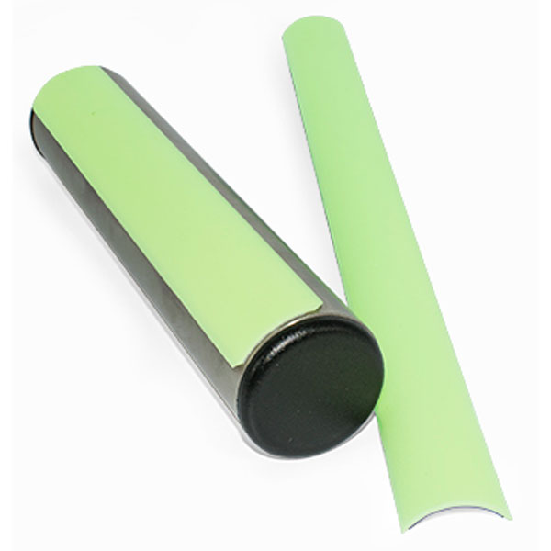
Preparation

Installation
Please read the complete instructions carefully before beginning any work.
- The temperature of the product being installed and the surface it is being installed on must be at least 60 degrees.
- Surfaces must be clean, smooth and non-porous. Install a sample piece of the strip material for 24 hours on the application surface to ensure that the strip adheres properly before doing a complete project installation.
- Gloves should be used when handling and installing the strip to prevent injury.
Note: These are finished products and need to be stored in a clean and dry location. Strips have a shelf life of up to nine months from the date of shipment.
Installation
The handrail strip shall be placed on the top surface of the handrail for its entire length, this includes extensions and newel post caps. Where handrails or extensions bend or turn corners, the strip must not have a gap of more than 4 inches (figure 1).
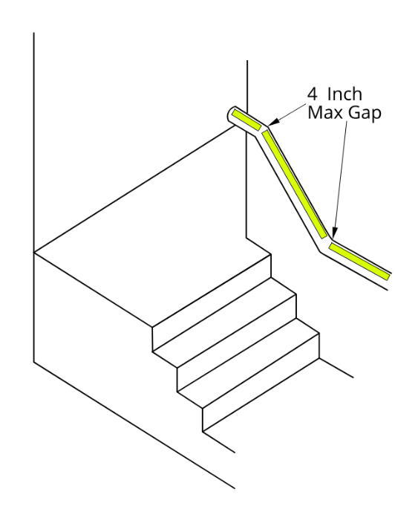
- Thoroughly clean the surface area where the strip will be installed with a dry cloth and a non‐residue cleaning compound to remove and loose particles and dirt. For oily surfaces, isopropyl alcohol works well for surface preparation. Surfaces must be dry and dust free.
- Measure the handrail to determine the proper length of the strip and then cut with scissors. The ends of the strip that will be a starting or ending segment need to be lightly beveled with a file to create a smooth transfer from the strip to the railing.
- Peel a portion of the backing from the handrail strip without touching the adhesive.
- Place the strip at your starting point on the railing and firmly press onto the handrail. Peel more backing from the adhesive strip as you go. Make sure the strip is straight and properly centered along the top length of the handrail. Be sure that the strip has full contact with the railing, this may involve using a rubber roller to ensure proper adhesion.
Figure 1

Operation
- Exposure Requirements: The minimum amount of exposure to artificial ambient illumination is 60 minutes from the following:
    - One-foot candle (11 Lux) of florescent, incandescent or LED light
- The control of the ambient illumination necessary to charge the luminous egress-path-marking system should be restricted to authorized personnel only.
- Failure to supply the above minimum exposure can prevent the luminous egress-path-marking from performing as intended.
- No specific building surface treatment is required for the luminous egress-path-marking system to function properly.
- Reliable external illumination is required at all times during building occupancy.

- Maintain by cleaning as needed to prevent dirt, etc. from inhibiting the performance of the photoluminescent properties.
- The strip may be cleaned by using a damp cloth with mild, non‐abrasive cleaners. Do not us highly alkaline or acidic cleaners. Rinse after applying cleaners and wipe with a clean cotton cloth to dry.

Maintenance

Nystrom warrants all Luminous Egress Products to be free from manufacturing defects in materials, factory finishes and workmanship from the date of shipment for a period of:

Standard Warranty
1 Year
Should a product fail to function in normal use within this period, Nystrom shall furnish a replacement or new part at Nystrom’s discretion.
Failure to use product in methods consistent with Nystrom product manuals shall relieve Nystrom of any liability.
Our liability under this warranty excludes installation or removal costs involved in the product replacement and excludes any responsibility for incidental or consequential damage of any nature.
Customer Actions for Claims on Product During Warranty Period

- Contact the Customer Service Department, Nystrom, Minneapolis, MN, Telephone: 763.488.9200, to obtain a Return Material Authorization (RMA) number.
- You will be sent an “RMA” that is required to be filled out and returned with the shipment.
- The following information must appear on the outside of the package:
  - RMA number marked on the outside of box
- Return defective product FREIGHT PREPAID. Collect shipments will be refused.
- The factory will not process warranty claims until the customer has properly accomplished the above items.
- Nystrom may accept the entire claim; part or none of the claim if our inspection of the returned parts proves the failure was for reasons other than defective material or factory workmanship.
Important Notes
- Nystrom will not be responsible for damage incurred during the return shipment.
- All returns subject to inspection and a $50 evaluation fee
- This RMA is not authorization for credit. Credits and/or replacements will be issued upon evaluation of returned product.
- RMA is valid for thirty (30) days from issue date.

Factory Assistance
Nystrom engineers and manufactures luminous egress products for worldwide customers. Our products enable safe exiting in egress stairways. Recognized as an industry leader, Nystrom has been relied upon by building and construction professions for over 70 years and we pride ourselves in offering exceptional technical support.
Please do not return any product before discussing your application problem with a Nystrom representative and obtaining a Return Authorization.
Your Nystrom representative is eager to help you. Please feel free to call your representative or contact Nystrom to discuss your application.
Nystrom
9300 73rd Avenue North
Minneapolis, MN 55428

Phone: 800.547.2635
Fax: 800.317.8770
Email: info@nystrom.com

