July 1, 2019
RE: H20 Drainable Floor Door Product Change Notice
The following design updates have been incorporated into the standard size single and double leaf aluminum H20 Drainable Floor Doors:
Single Door
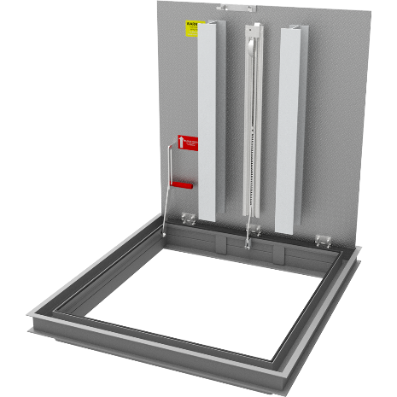
Model: FDDHA_X_SFL
- Extruded aluminum, drainable frame used in 300 PSF doors
- Spring housing identical to housing used in aluminum 300 PSF floor doors
- Integral gasket in frame
- New 5 inch I-beam stiffener, welded vertically
- Updated HOA identical to HOA in aluminum 300 PSF floor doors
- New 2 inch by 2-1/2 by 1/4 inch support shelf
- Overall frame depth change from 6-1/2 inches to 5-1/2 inches

Double Door
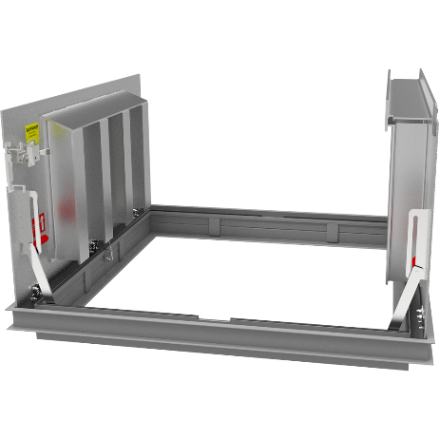
Model: FDDHA_X_DFL
- Extruded aluminum, drainable frame used in 300 PSF doors
- Spring housing identical to housing used in aluminum 300 PSF floor doors
- Integral gasket in frame
- New 5 inch I-beam stiffener, welded vertically
- Updated HOA identical to HOA in aluminum 300 PSF floor doors
- New 2 inch by 2-1/2 inch by 1/4 inch support shelf
- Overall frame depth change from 6-1/2 inches to 5-1/2 inches
- Removal of gutter between door, replaced by gasketed plate

Quoting will begin July 1, 2019. Please contact us at 1.800.547.2635 should you have any questions or concerns. We appreciate the opportunity to service you.

