Model(s): EJ FHES2
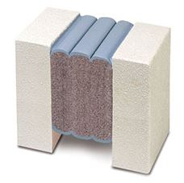
Preparation
- Locate the packing slip(s) and shop drawings.
- Verify that all products listed on the packing slip are included in the package.
- Check the products for damage. If products are damaged, report a freight claim immediately and leave the products in their packaging. If you sign for products without reporting damage you waive your right to a freight claim and will be responsible for their replacement cost.
- Read the instructions thoroughly before beginning installation.

Tools List
- Tape Measure
- Heavy duty, low speed, high torque drill
- Sausage gun for 20 oz silicone tubes
- Sausage gun for 20 oz intumescent tubes
- Chemical-resistant gloves
- 2-inch wide margin trowels
- Long bladed, serrated bread knife
- Hacksaw
- Spray bottle with water
- Masking tape (2-1/2 times the length)
- Minimum 2 each 1-1/2 inch dia. “jiffy mixers”
- Spatula to scrap epoxy from can
- 1/2 and 1 caulk knives for tooling sealant bands
- Acetone for cleaning joint face
- Clean lint-free 100% cotton rags

Cold Days: Store sealant, off the floor, inside at above 68°F. It will recover slower when cold and faster when warm.
Very Hot Days: Keep sealant out of direct sun when the temperature is greater than 60°F until immediately prior to installation into joint.
Pre-Installation
Concrete:
- Remove loose particles and weak or unsound concrete or other substrate materials to ensure a solid, sound substrate. Spalls, chipped edges and uneven surfaces must be repaired using proper material and methods to ensure maintenance of the fire-rated wall assembly construction. Joint faces must be parallel.
- Joint must have unobstructed depth greater than or equal to the full depth of the largest material supplied plus 1/2 inch (6mm).
- Dry all wet surfaces
- Wipe joint faces with dampened, lint free rags to remove all concrete dust and contaminants
Metal:
- Solvent-wipe immediately prior to applying FHES2 epoxy.
IMPORTANT: Ensure that there is no oxidation (rust) on metal substrate before the epoxy is applied.
Installation
A
A
- Measure Joint Width & Find Correct Size Material
  - Measure joint width at wall surface and inside of the gap to ensure joint faces are parallel.
  - Material has been supplied to suit your mean temperature field-measured joint widths. Widths of material supplied are marked on each stick of material. Find correct box and open it.
  - Compare width of material supplied as marked on each stick against mean joint width. Actual width of material as measured between hardboard will be slightly less than marked size because material is over-compressed for ease of installation.
IMPORTANT: Do not remove outer plastic packaging until you have read and understand the rest of these instructions as material may expand before you can get it into joint.
- Mask Walls & Mix Epoxy Adhesive
  - Tape off the walls on both sides of the joint.
- Mix Epoxy
  - Epoxy adhesive may be used in the 41° to 95° temperature range.
  - Using a trowel, transfer the entire contents of part B (Hardener) into the contents of part A (Base).
  - Mix the material thoroughly with a drill and mixing paddle. Scrape the walls and bottom of the container to ensure uniform and complete mixing.
  - Always mix component B (Hardener) into component A (Base). Ensure that a uniform gray color with no black or white streaks is obtained.
IMPORTANT: DO NOT thin the epoxy
- Apply Epoxy and Open Plastic Packaging
  - Ensure that the mixed epoxy adhesive is applied to the substrate before the pot life has expired (10-30 minutes depending on the ambient temperature).
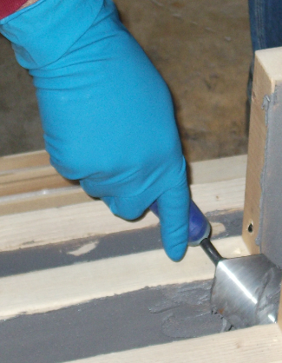
  - Warning: The epoxy will harden more quickly when left in the pot. Apply it onto the joint face as soon as possible.
  - IMPORTANT: The epoxy must still be uncured when installing FHES2 foam into the joint opening.
  - If the epoxy cures before installing the FHES2 foam, then reapply new epoxy. If work is interrupted for more than 2 hours after initial cure the grind the old epoxy, solvent wipe, and apply new wet epoxy.
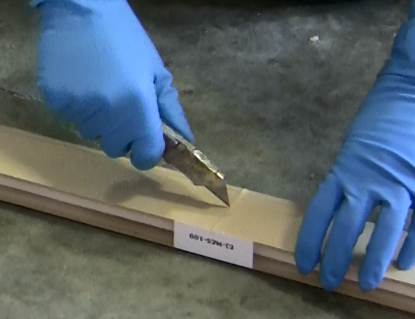
  - IMPORTANT: While one or more workers are applying epoxy to the joint faces, others must prepare the FHES2 foam. The FHES2 foam is kept under compression by plastic wrapping and hardboard on both sides.
  - When ready to install, slit the plastic wrapping by cutting on the hardboard, discard the hardboard and inner release liner.
  - DO NOT CUT ALONG SILICONE-COATING FACE. YOU MAY CUT THROUGH IT, THUS DAMAGING SEAL.
  - IMPORTANT: Work quickly and deliberately after cutting the shrink-wrap to avoid material expanding beyond a usable size.
- Wipe Release Agent off Silicone Facing
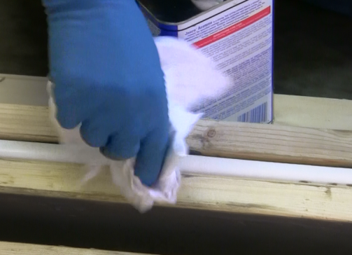
  - For packaging and protection reasons, the silicone facing is coated in the factory with a release agent.
  - Prior to installation, this agent must be wiped off using a solvent in order for the fillet beads described in step 8 to adhere to the silicone facing and to avoid contamination of the substrate at this point.
  - Lightly, quickly and thoroughly wipe the cured silicone facing with a lint free rag made damp with acetone or other solvent to remove the release agent.
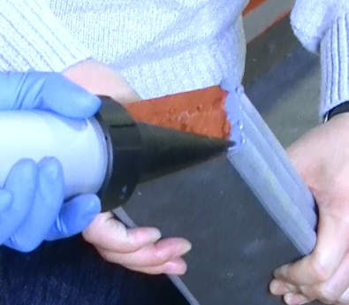
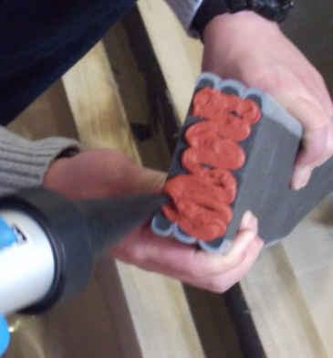
- Apply Silicone & Intumescent Caulk to Bellows Facing
  - On the end of the first stick, using a caulk gun and the tubes of silicone provided, apply the liquid silicone to the exposed faces of the silicone bellows.
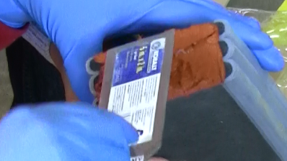
  - Using a sausage gun and the sausage of intumescent sealant provided, apply the intumescent sealant to the exposed face of the foam.
  - Use a caulk knife to spread the intumescent sealant over the face of the foam to an even 1/16th inch thickness.
  - Starting at the bottom of the joint, install the FHES2 foam into the joint. Ensure that the epoxy on the joint face has not cured.
  - Note: When material is correctly expanded for a snug fit it will support its own weight in the joint.
  - Feed material into the joint, starting from one end. The material should fit snugly and must be eased into the joint with steady, firm pressure.
  - When installed, the FHES2 must be recessed so that the top of the outward-facing bellows is flush or slightly set back from the wall surface.
  - Repeat step #5 for each new stick.
  - IMPORTANT: All sticks of FHES2 foam MUST have a coating of intumescent on the faces of all joints. This ensures that joins do not compromise the fire barrier.

- Install Next Length. Repeat
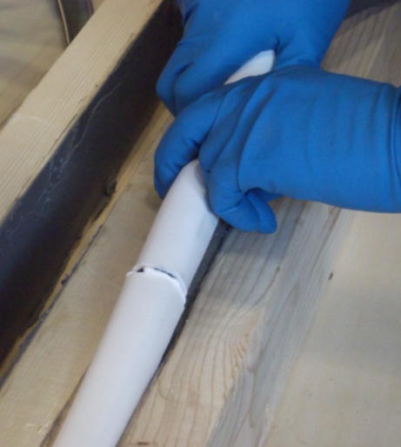
  - Work in one direction towards the previously installed length or end of joint. Do not stretch material.
  - Coat the top end of the next step with silicone and intumescent caulk as described in step 6 above.
  - Insert the uncoated bottom end of the stick into the joint and line it up with the previously installed stick.
  - Push Hard on the stick to compress the joint firmly together. Ensure there are no voids at joints.
  - During low temperature installation, provide as much ambient heat as possible around installed FHES2 foam to accelerate recovery.
  - Using a caulk knife, tool any silicone that squeezes out of the joint and blend it into the procured silicone bellows. Be sure not to fill in the valleys of the bellows as this will constrain movement.

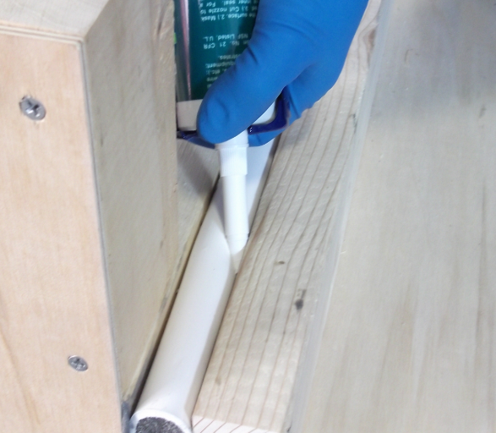
- Inject Silicone Sealant Bands at Substrates & Tool Excess Silicone
  - Wipe any excess epoxy from the face of material using a clean rag.
  - Before the epoxy cures, force the tip of the silicone caulk tube between the substrate and the FHES2 foam. Inject a ¾ inch deep silicone sealant band between the foam, cured silicone facing and the joint face.
  - Tool the freshly applied silicone firmly to blend with the substrates and cured silicone facing, and to ensure a proper bond and seamless appearance.
  - Where FHES2 foam meets the butt joints, tool the excess silicone that squeezes out from the top and between the bellows. IMPORTANT: Silicone left between the wrinkles of the bellows could constrain movement – using a caulk knife, remove excess sealant and blend what remains into the bellows. NOTE: Silicone sealant band is only applied to the weather side of the FHES2 foam. No sealant band is needed on the other side.

- Silicone-Coat Any Exposed Foam Ends:
  - IMPORTANT: Any stick of FHES2 which finished with an open end, not terminating into another stick of structural termination, must be lightly coated on the exposed foam end using the liquid silicone sealant provided. This is critical to ensure that the fire-retardant impregnated foam is sealed.
Operation
Expansion joints are designed and built for years of dependable service.
Maintenance
- Expansion Joints should be cleaned routinely.
- Exposed surfaces can be cleaned with a mild water-based cleaning solution. Wipe clean with a sponge or soft cloth.
- If any questions arise during the operation or maintenance of the products, please feel free to call our toll-free number for assistance, 1-800-547-2635 for technical support.

