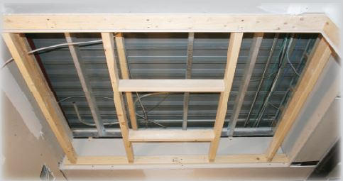
1. Frame the opening

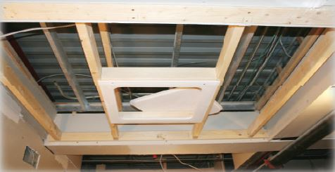
3. Mount frame into place

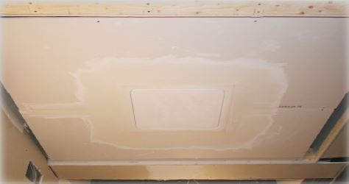
5. Tape and apply drywall compound

Model(s): GFR

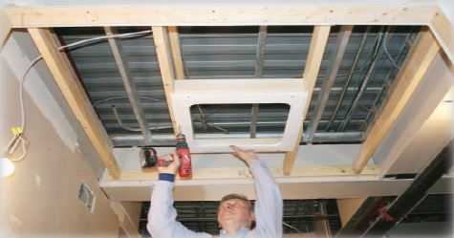
2. Mount Seamless™ surround with drywall screws

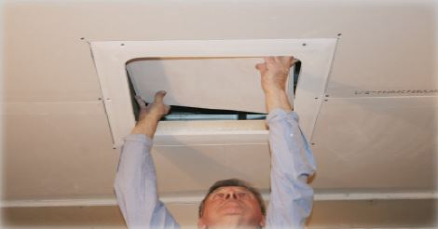
4. Install drywall and place access panel in opening

6. Apply desired finish

