Model(s): EJ HES

Preparation
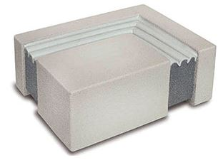
- Locate the packing slip(s) and shop drawings.
- Verify that all products listed on the packing slip are included in the package.
- Check the products for damage. If products are damaged, report a freight claim immediately and leave the products in their packaging. If you sign for products without reporting damage you waive your right to a freight claim and will be responsible for their replacement cost.
- Read the instructions thoroughly before beginning installation.

Tools List
- Tape Measure
- Heavy duty, low speed, high torque drill
- Caulking gun for 10 oz silicone tubes
- Chemical-resistant gloves
- 2-inch wide margin trowels
- Long bladed, serrated bread knife
- Hacksaw
- Masking tape (2-1/2 times the length)
- Minimum 2 each 1-1/2 inch dia. “jiffy mixers”
- Spatula to scrap epoxy from can
- 1/2 and 1 caulk knives for tooling sealant bands
- Acetone for cleaning joint face
- Clean lint-free 100% cotton rags
- Spray bottle with water

Cold Days: Store sealant, off the floor, inside at above 68°F. It will recover slower when cold and faster when warm.
Very Hot Days: Keep sealant out of direct sun when the temperature is greater than 60°F until immediately prior to installation into joint.

Pre-Installation
Concrete:
- Remove loose particles and weak or unsound concrete or other substrate materials to ensure a solid, sound substrate. Spalls, chipped edges and uneven surfaces must be repaired using proper material and methods to ensure maintenance of the fire-rated wall assembly construction. Joint faces must be parallel.
- Joint must have unobstructed depth greater than or equal to the full depth of the largest material supplied plus 1/2 inch (6mm).
- Remove all contaminants by sandblasting or grinding to ensure a thoroughly clean and sound substrate for the full sealant depth.
- NOTE: DO NOT use a wire wheel – this will polish the substrate and cause bond-failure.
- Dry all wet surfaces
- NOTE: Do not use flame to dry substrate – this will leave carbon on the substrate and cause bond failure.
- Wipe joint faces with dampened, lint free rags to remove all concrete dust and contaminants
Metal:
- Sandblast or grind to rough, white metal and solvent-wipe immediately prior to applying HES epoxy.
IMPORTANT: Ensure that there is no oxidation (rust) on metal substrate before the epoxy is applied.
A
A

Installation
- Measure Joint Width & Find Correct Size Material
  - Measure joint width at wall surface and inside of the gap to ensure joint faces are parallel.
  - Material has been supplied to suit your mean temperature field-measured joint widths. Widths of material supplied are marked on each stick of material. Find correct box and open it.
  - Compare width of material supplied as marked on each stick against mean joint width. Actual width of material as measured between hardboard will be slightly less than marked size because material is over-compressed for ease of installation.
IMPORTANT: Do not remove outer plastic packaging until you have read and understand the rest of these instructions as material may expand before you can get it into joint.
- Mask Walls & Mix Epoxy Adhesive
  - Tape off the walls on both sides of the joint.
- Start With Universal-90 Installation
  - Changes in plane, either up or down, require the use of factory fabricated Universal-90’s from Nystrom.
  - Sequencing: Install factory fabricated transition and/or termination pieces first. Connect straight run material to in place terminations and transitions.
  - Note: If installing very long runs of material, to avoid having to work at distances ends of a joint run and in order to prevent epoxy from curing, the final factory fabricated Universal-90 termination can be installed as the second to last piece.
  - Cut closing pieces 3/8 inch longer than the opening to be joined. Compress material longitudinally to fit.
- Mix Epoxy
  - Epoxy adhesive may be used in the 41° to 95° temperature range.
  - Using a trowel, transfer the entire contents of part B (Hardener) into the contents of part A (Base).
  - Mix the material thoroughly with a drill and mixing paddle. Scrape the walls and bottom of the container to ensure uniform and complete mixing.
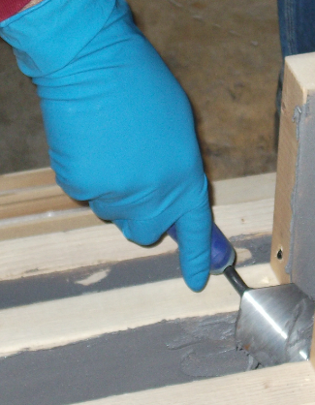
  - Always mix component B (Hardener) into component A (Base). Ensure that a uniform gray color with no black or white streaks is obtained.
IMPORTANT: DO NOT thin the epoxy
- Apply Epoxy and Open Plastic Packaging
  - Ensure that the mixed epoxy adhesive is applied to the substrate before the pot life has expired (10-30 minutes depending on the ambient temperature).
  - Warning: The epoxy will harden more quickly when left in the pot. Apply it onto the joint face as soon as possible.
  - IMPORTANT: The epoxy must still be uncured when installing HES foam into the joint opening.
  - If the epoxy cures before installing the HES foam, then reapply new epoxy. If work is interrupted for more than 2 hours after initial cure the grind the old epoxy, solvent wipe, and apply new wet epoxy.
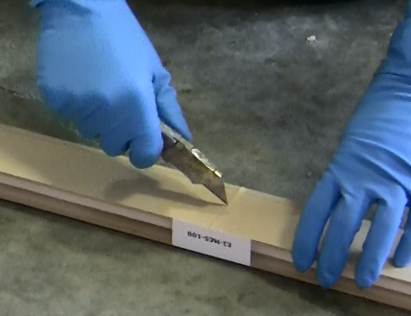
  - IMPORTANT: While one or more workers are applying epoxy to the joint faces, others must prepare the HES foam. The HES foam is kept under compression by plastic wrapping and hardboard on both sides.
  - When ready to install, slit the plastic wrapping by cutting on the hardboard, discard the hardboard and inner release liner.
  - DO NOT CUT ALONG SILICONE-COATING FACE. YOU MAY CUT THROUGH IT, THUS DAMAGING SEAL.
  - IMPORTANT: Work quickly and deliberately after cutting the shrink-wrap to avoid material expanding beyond a usable size.
- Wipe Release Agent off Silicone Facing
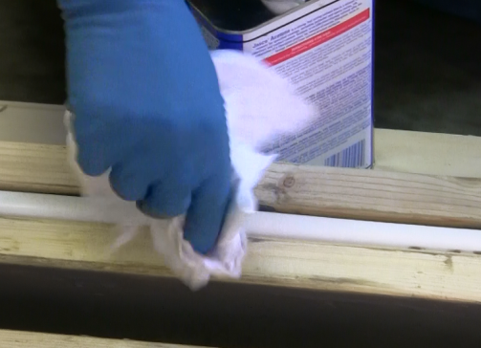
  - For packaging and protection reasons, the silicone facing is coated in the factory with a release agent.
  - Prior to installation, this agent must be wiped off using a solvent in order for the fillet beads described in step 8 to adhere to the silicone facing and to avoid contamination of the substrate at this point.
  - Lightly, quickly and thoroughly wipe the cured silicone facing with a lint free rag made damp with acetone or other solvent to remove the release agent.
- Install First HES Foam Length Into Joint & Apply Silicone to Bellows Facing
  - When installing the foam into the joint, ensure that the epoxy on the joint face has not cured.
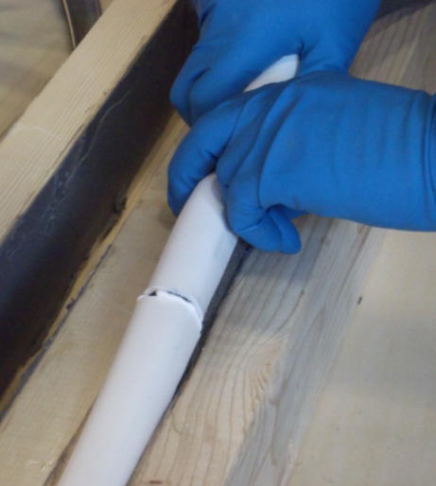
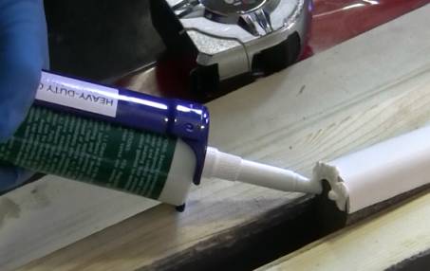
  - When installed, the HES must be recessed so that the top of the outward-facing bellows is flush or slightly set back from the wall surface.
  - Note: When material is correctly expanded for a snug fit it will support its own weight in the joint.
  - Feed material into the joint, starting from one end. The material should fit snugly and must be eased into the joint with steady, firm pressure.
  - Leave the end of the stick to the next length sticking slightly out of the joint.
  - Repeat step #6 for each new stick.
  - On the end of the next stick, using a bulk gun and the sausages of silicone provided, apply the liquid silicone to the exposed face of the silicone bellows. Avoid spreading silicone sealant to foam.

- Install Next Length. Repeat
  - Work in one direction towards the previously installed length or end of joint. Do not stretch material.
  - Leave the end to be joined to the previous length sticking out of the joint – push the joining faces together.
  - Push Hard on the stick to compress the joint firmly together. Ensure there are no voids at joints.
  - Once the full length is installed, push the protruding stick into the joint and tool off the excess silicone.
  - During low temperature installation, provide as much ambient heat as possible around installed HES foam to accelerate recovery.

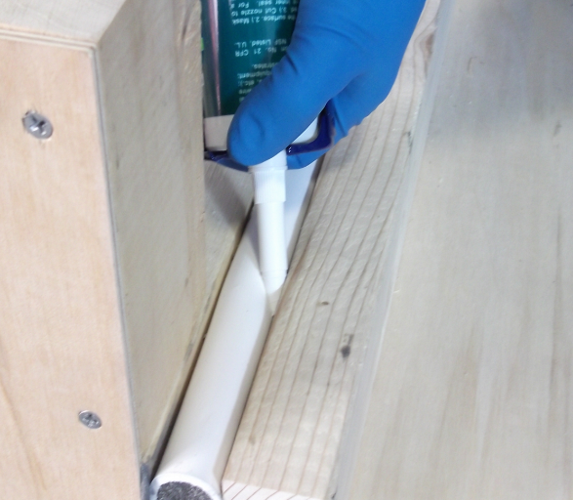
- Inject Silicone Sealant Bands at Substrates & Tool Excess Silicone
  - Wipe any excess epoxy from the face of material using a clean rag.
  - Before the epoxy cures, force the tip of the silicone caulk tube between the substrate and the HES foam. Inject a 3/4 inch deep silicone sealant band between the foam, cured silicone facing and the joint face.
  - Tool the freshly applied silicone firmly to blend with the substrates and cured silicone facing, and to ensure a proper bond and seamless appearance.
  - Where HES foam meets the butt joints, tool the excess silicone that squeezes out from the top and between the bellows. IMPORTANT: Silicone left between the wrinkles of the bellows could constrain movement – using a caulk knife, remove excess sealant and blend what remains into the bellows.

- Transitions, Ends, and Special Conditions:
  - Sequencing:
    - Install factory-fabricated transition and/or termination pieces first. Connect straight run material to in-place terminations and transitions. Apply the joining silicone (at the bellows ends only) on the straight length before inserting it into the joint (see step #7). Bring the stick firmly against the butt end of the already installed Universal-90 and push the straight run stick towards this join throughout the process of installing it.
    - Note: If installing very long runs of material, to avoid having to work at distant ends of a joint run and in order to prevent epoxy from fully curing, the final factory-fabricated Universal-90 termination can be installed as the second-to-last piece.
    - Cut closing pieces 3/8 inch (10mm) longer than the opening to be joined. Compress material longitudinally to fit.
  - UNIVERSAL-90 TRANSITIONS:
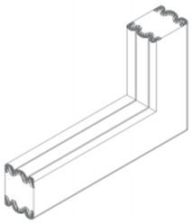
    - Universal-90’s are designed to continue the HES through changes in plane such as at floor-to-walls, curbs, treads and risers, or other such changes in slab thickness. Unlike straight-run lengths, BOTH sides of Universal-90’s are silicone coated with bellows so there is no top or bottom. They can be turned over to be used either as an upturn or a downturn. Install factory-fabricated transition and/or termination pieces first. Universal-90’s may also be used to transition to another Nystrom foam product.

    - Connect straight run material to in-place terminations and transitions (see step #7). Cut closing pieces 3/8-inch (10mm) longer than the opening to be joined. Compress material longitudinally to fit.
  - UNIVERSAL-90 TERMINATIONS:
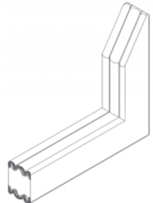
    - When HES does not run in a closed loop it needs to be terminated with a factory-fabricated Universal-90. Prepare gap with epoxy adhesive in the same manner as the
HES sticks. As with Universal-90 transitions, install factory-fabricated transition and/or termination pieces first.
    - Connect straight run material to in-place terminations and transitions (see step #7).
Cut closing pieces 3/8 inch (10mm) longer than the opening to be joined. Compress material longitudinally to fit. The factory-sealed end acts as the termination and points up or down to best block or direct water flow.
  - FLAT CORNERS:
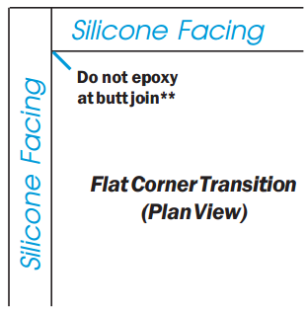
    - Work towards the corner so that the last two pieces to install will join at the corner.
    - Cut each piece to be joined 3/8 inch (10 mm) longer than needed.
    - Install one piece so that it runs through the intersecting joint-gap. Firmly push and compress the extra length so that a tight fit in the corner is achieved.
    - Firmly butt intersecting pieces into sides of already placed material.
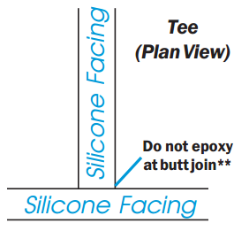
    - **IMPORTANT: Be sure that there is no epoxy on the sides or faces of foam at a butt join.
    - Using a caulk knife, remove any excess sealant and blend the liquid silicone into the bellows to preserve the bellow shape.
    - NOTE: The extra length will make it a tight fit—this results in a compression fit.
    - Inject a bead of liquid silicone where the silicone faces join
  - CROSSES AND TEES:
    - Run one piece of material across the intersection. Coat silicone bellows end (only) of the intersecting material with silicone. Firmly butt intersecting pieces into sides of already placed material.
    - Using a caulk knife, remove any excess sealant and blend the liquid silicone into the bellows to preserve the bellows shape.
  - CROSSES AND TEES:
    - IMPORTANT: If the HES runs are not part of a closed loop system, and Universal-90 terminations are not used (run does not terminate in an upturn or downturn), lightly coat any exposed foam ends using the liquid silicone sealant provided. This is critical in ensuring that the water-tightness of the foam is sealed.

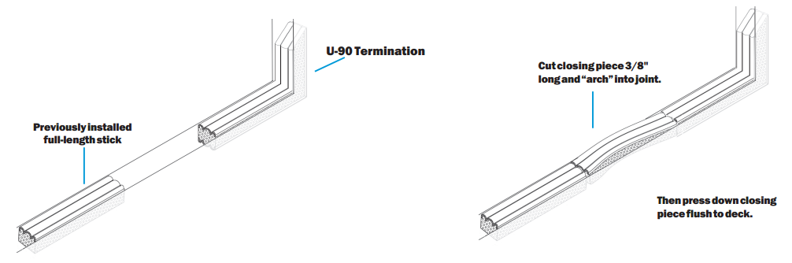
Operation
Expansion joints are designed and built for years of dependable service.
Maintenance
- Expansion Joints should be cleaned routinely.
- Exposed surfaces can be cleaned with a mild water-based cleaning solution. Wipe clean with a sponge or soft cloth.
- If any questions arise during the operation or maintenance of the products, please feel free to call our toll-free number for assistance, 1-800-547-2635 for technical support.

