Vinyl Handrail
Models: HRVE15C

Important Notes:

- Locate and install Crash Rail in accordance with architectural drawings and specifications. When required, shop drawings should be used in conjunction with these documents
- Locate the packing slip(s) and inspect all material for damages or missing parts. If products are damaged, notify the factory immediately and leave the products in their packaging. If products are signed and received without reporting damages, you waive your right to a freight claim and will be responsible for their replacement cost.
- Store material in a clean, dry location at room temperature between 65° F (18° C) and 77° F (25° C) for at least 24 hours prior cutting and installing to minimize expansion and contraction of materials.
- Read the instructions thoroughly before beginning installation.

Vinyl Hand Rails

- Lay out the work to be completed, including all component parts, along the base of the wall. Check the material for any damage that may have occurred during shipment and/or handling at the job site.
- Snap a chalk line at the proper location on the wall to ensure a level installation. Chalk line should be calculated to the center line of the mounting bracket wall fasteners.
- Measure and cut aluminum retainer, making appropriate allowance for end and corner caps.
Note: Cut aluminum retainer square to assure a neat joint when vinyl bumper cover is assembled and butted to ends and corners.
- Debur ends of aluminum retainer before assembly to improve fit of end and corner caps and reduce risk of nicks or scratches.
- Utilize splice kit for runs exceeding aluminum retainer max length.
- Pre-drill retainer with 1/8" (3.2mm) drill bit to allow fastening of end caps, corner caps, and mounting brackets. For end and corner caps drill holes 1/2" (12.7mm) in from end of retainer (see drawings). Brackets need placed within 6" (152.4mm) of each other, max bracket spacing is 32" (812.8mm) on center.
- Attach end and corner caps with #8 x 1/2" (12.7mm) screw (included).
- Attach brackets with #8 x 3/4" (19.1mm) screw (included).
- Mark, drill, and fasten aluminum retainer with end and corner caps to brackets with fasteners (not included) using care to ensure square with retainer.
- Measure, cut, and install cover. Remove any flash cut with deburring tool or small knife.
Note: All crash rail and handrail material is provided in 20’-0” stock lengths to be cut in the field. A 80-100 tooth, carbide tip saw blade or equivalent is recommended for cutting the material to minimize chipping. If this distance exceeds stock length, position seam of profile directly over the splice (connector plates) of the aluminum retainer. It is recommended that the cover be cut slightly oversize to provide proper alignment between the caps.
- If you have any questions during installation, please contact Nystrom.

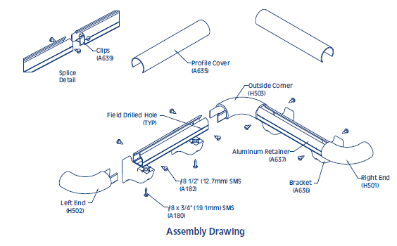

Installation Dimensions for HRVE15C
Maintenance:
- Use mild detergent to clean soiled surfaces. Pen marks, paint and graffiti generally wash off easily with mild soap and water. Completely rinse the surface with clean water when complete.
Note: Powdered cleansers and bleach cleaners should be used with care as they may leave a residue embedded in the cover surface. Properly rinsing with clean water will remove any residual residue.
- Tough marks or stains may require a heavy duty cleaner such as “Crown Anti-Vandal Spray” or “DWR-II”. These specialized spot cleaners should only be used on small areas and tested for color fastness prior to applying in a highly visible area. Rinse thoroughly with clean water to remove the residue from these cleaners.

