Vinyl Handrail
Models: HRVE6C-AS

Important Notes:

- Locate and install Crash Rail in accordance with architectural drawings and specifications. When required, shop drawings should be used in conjunction with these documents
- Locate the packing slip(s) and inspect all material for damages or missing parts. If products are damaged, notify the factory immediately and leave the products in their packaging. If products are signed and received without reporting damages, you waive your right to a freight claim and will be responsible for their replacement cost.
- Store material in a clean, dry location at room temperature between 65° F (18° C) and 77° F (25° C) for at least 24 hours prior cutting and installing to minimize expansion and contraction of materials.
- Read the instructions thoroughly before beginning installation.

Vinyl Hand Rails

- Lay out the work to be completed, including all component parts, along the base of the wall. Check the material for any damage that may have occurred during shipment and/or handling at the job site.
- Snap a chalk line at the proper location on the wall to ensure a level installation. Chalk line should be calculated to the center line of the mounting bracket wall fasteners.
- Place the retainer in the proper position on the chalk line and mark hole locations using the proper bit size for fasteners.
Note: All crash rail and handrail material is provided in 20’-0” stock lengths to be cut in the field. A 80-100 tooth, carbide tip saw blade or equivalent is recommended for cutting the material to minimize chipping. The aluminum retainer has been supplied in stock lengths, it will be necessary for it to be field-cut. Determine the allowances necessary for door jambs, corner conditions, etc. (See back) and cut retainer to proper length. Drill 9/32" (7.1mm) holes at I.D. mark on retainer 3" (76.2mm) in from each end and all intermediate locations not to exceed 32" (812.8mm) O.C.
- Insert tabs on returns and corners into retainers, clamp into place, and secure with manufacturer-provided #8 x 1/2" (12.7mm) sheet metal screws or 1/8" (3.2mm) pop rivets.
- Assemble retainers. Splice abutting retainer lengths, if any, using manufacturer-provided splices and screws; abut tightly to achieve hairline joints.
- Mount assembly to wall using 1/4" (6.4mm) x 4" (101.6mm) fastener (not included). Feed fastener through retainer and mounting bracket. Attach and feed through wall. Tighten securely.
Note: Prior to installation of the cover, make sure that all fasteners are secure and properly seated.
- Install cover. Carefully locate cover joints so that they are not directly over retainer splices, as this can create improper alignment of adjacent cover lengths. Measure and cut cover lengths to fit between returns and corners exactly. Use longest practical lengths to minimize number of joints. Do not align cover joints directly over retainer joints. Secure cover lengths to retainer by hooking 4"(101.6mm) square cover over retainer top and snapping over retainer bottom, pushing 1-1/2"(38.1mm) round cover down over the top of the retainer, and sliding lengths of accent strip in to retainer slot from one end. Make all joints neat and hairline-tight.
- If you have any questions during installation, please contact Nystrom.

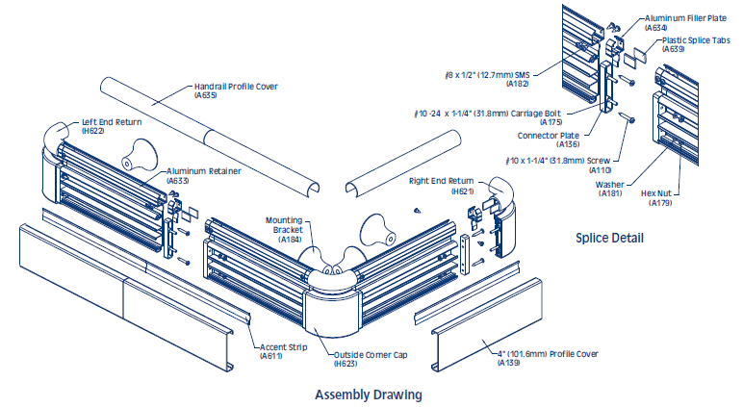

Installation Dimensions for HRVE6C-AS

Maintenance:
- Use mild detergent to clean soiled surfaces. Pen marks, paint and graffiti generally wash off easily with mild soap and water. Completely rinse the surface with clean water when complete.
Note: Powdered cleansers and bleach cleaners should be used with care as they may leave a residue embedded in the cover surface. Properly rinsing with clean water will remove any residual residue.
- Tough marks or stains may require a heavy duty cleaner such as “Crown Anti-Vandal Spray” or “DWR-II”. These specialized spot cleaners should only be used on small areas and tested for color fastness prior to applying in a highly visible area. Rinse thoroughly with clean water to remove the residue from these cleaners.

