Model(s): FX12SV, FG12SV
Prepare for Installation
- Locate the packing slip(s) and shop drawings.
- Verify that all products listed on the packing slip are included in the package.
- Check the products for damage. If products are damaged, report a freight claim immediately and leave the products in their packaging. If you sign for products without reporting damage you waive your right to a freight claim and will be responsible for their replacement cost.
- Read the instructions thoroughly before beginning installation.
Prepare the Mat for Installation
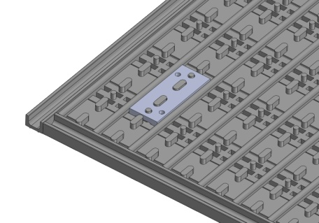
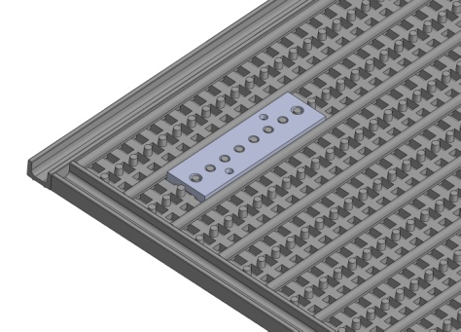
- Secure the mat retainers to each mat section. Each section will have at a minimum 4 retainers, one for each corner. Place the retainers approximately 2 rows in from the side and 5 sets of pegs from the bottom
MAXtread™ Retainer
MAXgrid™ Retainer
Install the Mat
- Clean the recess thoroughly. Note that debris will cause irregularities in the recess that may cause the mat to rock or create a tripping hazard.
- Using the mat retainer holes as a guide, drill holes for the mat retainers; drill directly through the mat sections and retainer hole.
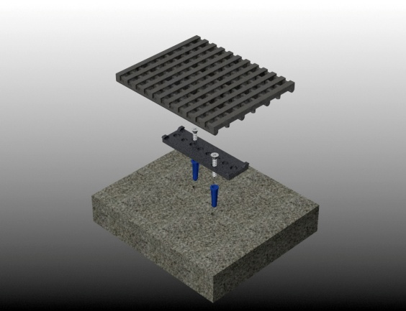
- Lift the mast sections and vacuum any dust.
- Hammer the blue screw sleeves into the holes.
- Replace the mat sections
- Drive the screws directly through the mat sections and retainers into the sleeves using a torque meter screw driver.
- Save the installation and maintenance instructions and include them with the closeout documentation for the owner and maintenance personnel.
maintenance
Continued maintenance is critical to the long-term safety and performance of the mat / grille. Remove the mat and clean the recess periodically to prevent the surface from becoming uneven. Debris build up within the recess could lead to deflection in the grille and may possibly cause tripping hazards.
The type and schedule of maintenance of your grille or mat will depend upon location and amount of traffic. See the outline below for cleaning instructions for the variety of tread insert materials.
- A good heavy-duty vacuum cleaner with a rotating brush is the most effective way to routinely clean the carpet in your entrance grille or mat. By vibrating the fibers, this type of vacuum not only cleans the surface of the carpet, but also removes soil that is imbedded into the pile. The rotating brush aids in keeping the pile upright for longer lasting beauty.
- The heaviest traffic areas should be vacuumed daily and the light traffic areas as infrequently as weekly.
- Carpet should be deep cleaned with a hot water extraction cleaner once per month or when vacuuming will no longer remove the soil. This may be monthly, quarterly, or longer, depending upon soil and traffic conditions.
- Inspect the grille or mat regularly for spots and stains, to reduce the possibility of them becoming permanent.
- Removing Spots
  - If the spot is semi-solid, scrape with a spoon or spatula and then blot with a damp sponge. Work from the edge of the spot to the center. This will keep the stain from spreading. If this procedure does not work, use a spot remover.
  - We recommend a dry system because it reduces solid build-up won’t leave floors wet and slippery, and there is no risk in damaging the carpet from dye bleeding. For most spills such as coffee, tea, pet stains, etc., a dry soil extractor works best.
  - Wet cleaning methods, including aerosols, foams, hot water extraction, or shampoo will work, but sometimes they leave sticky detergent residue that will accelerate soil build-up.
  - For oily stains such as tar, grease, paint, etc., a non-flammable dry cleaning solvent works best. Be extremely careful when using dry cleaning solvent. Take care to check for color fastness before cleaning the entire surface. Put a few drops of stain remover in an inconspicuous area and press the area with a clean cloth for ten seconds. If the color fades or changes, discontinue use.
Follow the tread maintenance instructions to ensure the long life of the grille tread. Contact Nystrom for information on replacing damaged treads.

