Renovation Stair Treads + Nosings
INSTALLATION, OPERATION + MAINTENANCE MANUAL
Model(s): STRB

Table of Contents

Table of Contents
General Description 3
Installation 4
Operation 6
Maintenance 7
Replacement Parts 8
Standard Warranty 9
Factory Assistance 10

Copyright
2019 by Nystrom, Inc. All rights reserved.

This document contains proprietary information. No part of this document may be reproduced without the prior written consent of Nystrom, Inc.

Note
The information in this document is subject to change without notice.

General Safety Precautions
Improper selection, installation, or use can cause personal injury or property damage. It is solely the responsibility of the user, through its own analysis to select products suitable for their specific application requirements, ensure they are properly maintained, and limit their use to its intended purpose.

Follow proper local, state and federal regulations for proper installation and operation requirements.

General Description
Stair treads and nosings are designed for years of safe passage. Proper installation is critical to the product performance. Locally accepted installation practices and procedures should be followed to ensure a safe stairway system that meets all local code requirements, including Occupational Safety and Health Administration (OSHA), Americans with Disabilities Act (ADA), International Code Council (ICC) and International Building Code (IBC).
The following is a general instruction for installing, operating and maintaining stair treads and nosings. These are general guidelines only.
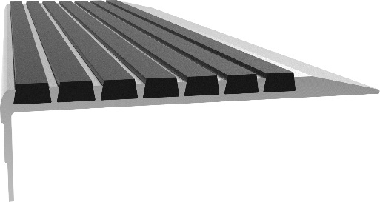
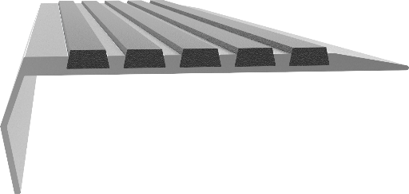
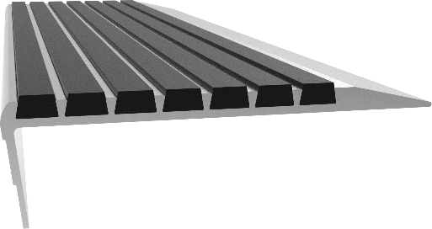
Preparation

Installation
Please read the complete instructions carefully before beginning any work.
- Verify that all products listed on the packaging slip are included in the package.
- Check product for damage.
Note: If damaged, report a freight claim immediately and leave the products in their packaging. If you sign for products without reporting damage, you waive the right to a freight claim.

Operation
- Clean substrate ensuring all loose debris is removed prior to installation.
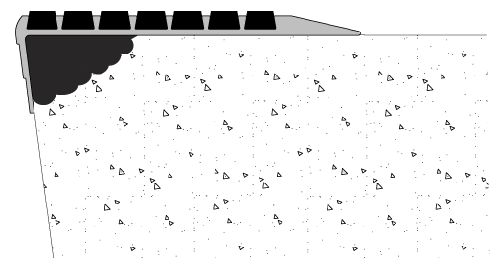
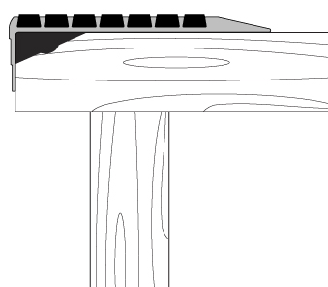
- In areas where concrete is dished or spalling, apply a quick-setting, self-leveling compound. If wood tread is rotted, replace (figures 1 and 2).
Figure 1
Figure 2
Note: Any voids left between the underside of the metal stair nosing and the substrate will allow flexing of the stair nosing itself. It is vital the installer make sure there is a clean and level surface under the stair nosing to totally seat onto the substrate and fully rest upon the riser return.

Operation
Tools Required

- Electric or hammer drill
- 3/16-inch drill bit
- Flat-head fasteners
- Caulk gun
- Exterior grade polyurethane construction adhesive
- Shop vacuum or compressed air
- Permanent marker

Installation
Renovation treads are designed to sit on top of existing stair riser return which provides total support for the nosing.
- Place nosing in desired location on tread. Using the pre-drilled holes as a guide, mark locations on substrate using permanent marker.

Installation
- In marked locations drill pilot holes appropriate for the fastener. When using concrete fasteners, please follow all instructions provided by the fastener manufacturer.
- Using shop vacuum or compressed air, free pilot hole of dust and debris created from drilling.
- Wipe clean the backside of nosing.
- Staying approximately 1/2-inch inside the perimeter of the nosing and around any holes, apply a 1/4-inch bead of construction adhesive to the back of the tread. Apply an equal sized bead around all holes and in a zigzag pattern, fill in the center are of the nosing.
- Place back into position, aligning nose flush to end of tread (figures 1 and 2).
- Secure nosing with appropriate fasteners in pre-drilled holes
Stair Material | Fastener Type
Masonry Steps | Expansion shields and flat-head screws
Metal Steps | Bolts and nuts or self-tapping flat-heat screws
Wood Steps | #10 wood flat-heat screws
Note: Stainless Steel fasteners are recommended for exterior steps.

Photoluminescent Option
- Exposure Requirements:

Operation
  - The minimum amount of exposure to direct sunlight is 60 minutes
  - The minimum amount of exposure to artificial ambient illumination is 60 minutes from the following:
    - Fluorescent straight tube T8 or T12, 4000 – 4500 K color temperature
    - Incandescent soft white 2700 – 3000 K color temperature
    - LED 2700 – 3000 K color temperature
- The control of the ambient illumination necessary to charge the luminous egress-path-marking system should be restricted to authorized personnel only.
- Failure to supply the above minimum exposure can prevent the luminous egress-path-marking from performing as intended.
- No specific building surface treatment is required for the luminous egress-path-marking system to function properly.
- Reliable external illumination is required at all times during building occupancy.

Keep stair treads and nosings free of debris and dirt by sweeping or vacuuming regularly. Heavy-duty commercial cleaners will not harm nosings but are generally not necessary. If nosings are damaged, please contact the factory for a repair kit or replacement nosings.
Cleaning
- Treads should be swept with a broom or vacuumed with a heavy-duty commercial vacuum cleaner at least once a week.
- When needed, scrub surface vigorously with a stiff bristled brush using a mild detergent. Do not use any product containing solvents, such as Acetone. It will break down the abrasive adhesive. We suggest using Murphy’s Oil Soap® or Simple Green®. Rinse thoroughly with water after cleaning.
- Scuff marks on the aluminum nose can be removed by rubbing with a fine steel wool and a commercial cleaning agent.
- To remove snow and ice, use deicing compounds such as calcium chloride or sodium chloride.
- DO NOT CLEAN WITH A PRESSURE WASHER

Maintenance
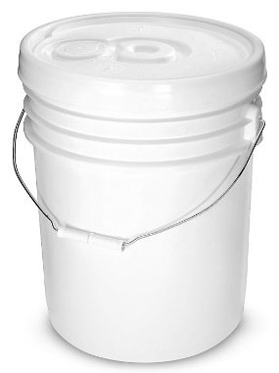

Replacement Parts
pART nUMBER | dESCRIPTION
ST-KIT-BLACK-1G | 1 Gallon bLACK aBRASIVE gRIT rEPAIR kIT
ST-kit-black-1q | 1 quart black abrasive grit repair kit
ST-KIT-C1-1q | 1 quart PHOTOLUMINESCENT ABRASIVE GRIT REPAIR KIT
ST-KIT-C2-1q | 1 quart BROWN ABRASIVE GRIT REPAIR KIT
ST-KIT-C3-1q | 1 quart BURGUNDY ABRASIVE GRIT REPAIR KIT
ST-KIT-C4-1q | 1 quart GRAY ABRASIVE GRIT REPAIR KIT
ST-KIT-C5-1q | 1 quart YELLOW ABRASIVE GRIT REPAIR KIT
ST-KIT-C6-1q | 1 quart GREEN ABRASIVE GRIT REPAIR KIT
ST-KIT-C7-1q | 1 quart RED ABRASIVE GRIT REPAIR KIT
ST-KIT-C8-1q | 1 quart BUFF/ORANGE ABRASIVE GRIT REPAIR KIT
ST-kit-c9-1q | 1 quart blue abrasive grit repair kit

REPAIR KIT
Contains Abrasive, Epoxy Hardener and Epoxy Resin

COLORS

Black | Yellow | 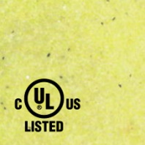  Photoluminescent
Brown | 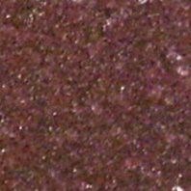  Burgundy | Gray | Green | 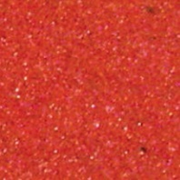  Red | 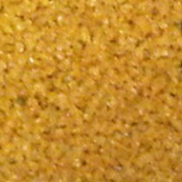  Buff/Orange

Nystrom warrants all Stair Treads and Nosings to be free from manufacturing defects in materials, factory finishes and workmanship from the date of shipment for a period of:

Standard Warranty
1 Year
Should a product fail to function in normal use within this period, Nystrom shall furnish a replacement or new part at Nystrom’s discretion.
Failure to use product in methods consistent with Nystrom product manuals shall relieve Nystrom of any liability.
Our liability under this warranty excludes installation or removal costs involved in the product replacement and excludes any responsibility for incidental or consequential damage of any nature.
Customer Actions for Claims on Product During Warranty Period
- Contact the Customer Service Department, Nystrom, Minneapolis, MN, Telephone: 763.488.9200, to obtain a Return Material Authorization (RMA) number.
- You will be sent an “RMA” that is required to be filled out and returned with the shipment.
- The following information must appear on the outside of the package:
  - RMA number marked on the outside of box
- Return defective product FREIGHT PREPAID. Collect shipments will be refused.
- The factory will not process warranty claims until the customer has properly accomplished the above items.
- Nystrom may accept the entire claim; part or none of the claim if our inspection of the returned parts proves the failure was for reasons other than defective material or factory workmanship.
Important Notes
- Nystrom will not be responsible for damage incurred during the return shipment.
- All returns subject to inspection and a $50 evaluation fee
- This RMA is not authorization for credit. Credits and/or replacements will be issued upon evaluation of returned product.
- RMA is valid for thirty (30) days from issue date.

Factory AssistanceImportant Notes

- Nystrom will not be responsible for damage incurred during the return shipment.
- All returns subject to inspection and a $50 evaluation fee
- This RMA is not authorization for credit. Credits and/or replacements will be issued upon evaluation of returned product.
- RMA is valid for thirty (30) days from issue date.

Factory Assistance
Nystrom engineers and manufactures stair tread and nosing products for worldwide customers. Our products enable safe exiting in stairways. Recognized as an industry leader, Nystrom has been relied upon by building and construction professions for over 70 years and we pride ourselves in offering exceptional technical support.
Please do not return any product before discussing your application problem with a Nystrom representative and obtaining a Return Authorization.
Your Nystrom representative is eager to help you. Please feel free to call your representative or contact Nystrom to discuss your application.
Nystrom
9300 73rd Avenue North
Minneapolis, MN 55428

Phone: 800.547.2635
Fax: 800.317.8770
Email: info@nystrom.com

