Model(s): EJ SER
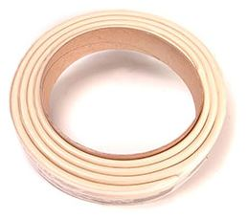
Preparation
- Locate the packing slip(s) and shop drawings.
- Verify that all products listed on the packing slip are included in the package.
- Check the products for damage. If products are damaged, report a freight claim immediately and leave the products in their packaging. If you sign for products without reporting damage you waive your right to a freight claim and will be responsible for their replacement cost.
- Read the instructions thoroughly before beginning installation.

Tools List
- Tape Measure
- 10-ounce Caulking Gun
- Long-Blade Utility Knife
- Caulk Knives
- Acetone & Lint-Free Rag
Cold Days: Store sealant, off the floor, inside at above 68°F (20°C). It will recover slower when cold and faster when warm.
Very Hot Days: Keep sealant out of direct sun when temperatures are greater than 60°F (15°C) until immediately prior to installation.
A
A
Pre-Installation
- Ensure joint faces are parallel and have sufficient depth to receive the full depth of the size(s) of SER product being installed plus at least 1/4 inch (6mm).
- Repair spalled, irregular or unsound joint surfaces using accepted industry practices for repair of the substrates in question. Remove protruding roughness to ensure joint sides are smooth.
- Remove residues of old sealants.
- Apply solvent or other agent suitable for use on the substrates in question to clean, lint-free rags.
- Wipe joint faces to ensure joint sides are free of dust, previous sealant, oils, grease, etc.
- Ensure joint sides are dry of solvent or cleaning agent prior to installation.
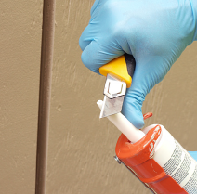
Installation
- Apply Installation Sealant Bead
  - Cut the tube tip to provide a 1/4 inch opening in the nozzle.
  - Pierce the tube foil to allow the sealant to flow.
  - Load the tube into the caulk gun.
  - Gun a 1/4 inch (6mm) wide mounting bead of sealant onto each joint face, about 3/8 inch (8mm) back from the joint edge.
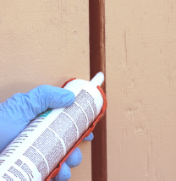
  - Strike the mounting bead of liquid sealant with a caulk knife to ensure that it is continuous, even, and properly bonded to the substrate.
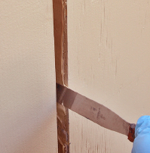
- Select and Open Material
  - Open a box marked with a material size to match the joint size.
  - Remove a reel from box.
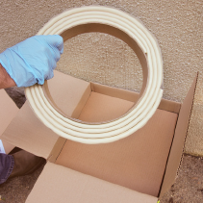
  - Cut the packaging tape.
NOTE: Be sure to cut away from the product so you don’t slice into the side of the seal. 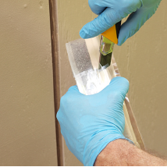
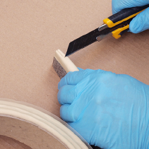
  - Peel back the packing tape and release liner at the beginning of the reel.
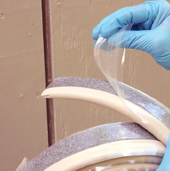
  - Extend the blade on your long-bladed utility knife.
  - Using a back and forth “sawing” motion, square off the end of the material.
- Wet Seal The Starter End
  - On the starter piece, apply a bead of sealant along the silicone coating.
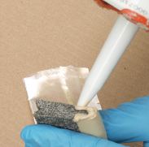
  - Uncoil the first end from the reel.
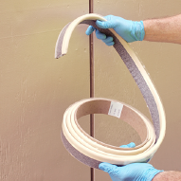
  - Insert the end into the bottom of the joint.
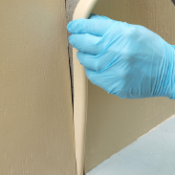
- Insert Material Into Joint
  - Work your way along the joint pushing on the material while inserting it.
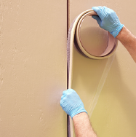
  - Remove the release liner as you go.
  - REMEMBER: ALWAYS PUSH, Never Pull. Do not stretch the material.
  - By pushing on the material is will “snake” into the joint from side to side.
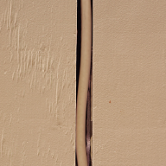
  - As it extends to fill the joint, it will also push along its length ensuring the joins and ends are a tight fit.
- Cut Material Slightly Longer Than Needed
  - Cut each run of material about 3/8 inch longer than needed.
  - “Snake” the excess into each run.
- Joining Straight Lengths
  - At the end of a roll, leave the end of the material sticking out of the joint about 3/4 inch.
  - As in step 4, apply a bead of sealant along the silicone edge.
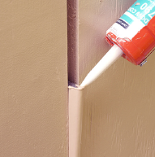
  - Open another reel, square off the end, and join it to the piece sticking out of the joint. 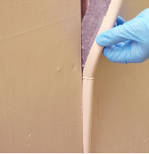
  - Push pieces firmly together.
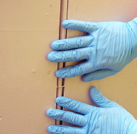
  - Install the rest of the joint run then come back and push the join into the joint.
  - Tool away the excess joining sealant and blend the join.
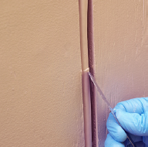
  - NOTE: For HORIZONTAL applications, finishing corner beads of silicone must be applied and tooled at both top edges.
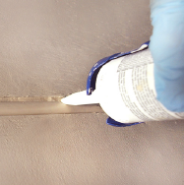

- Direction Changes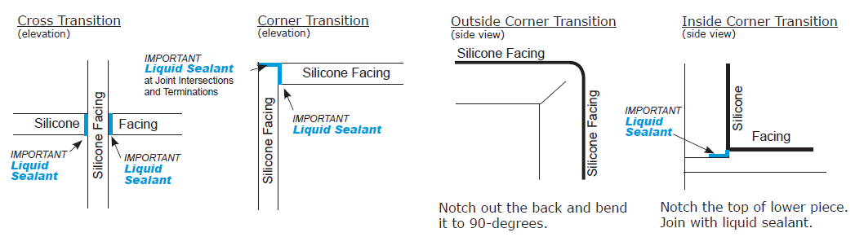

Operation
Expansion joints are designed and built for years of dependable service.

Maintenance
- Expansion Joints should be cleaned routinely.
- Exposed surfaces can be cleaned with a mild water-based cleaning solution. Wipe clean with a sponge or soft cloth.
- If any questions arise during the operation or maintenance of the products, please feel free to call our toll-free number for assistance, 1-800-547-2635 for technical support.

