Model(s): EJ SES, EJ PES
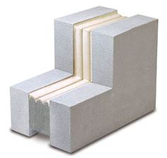
Preparation
- Locate the packing slip(s) and shop drawings.
- Verify that all products listed on the packing slip are included in the package.
- Check the products for damage. If products are damaged, report a freight claim immediately and leave the products in their packaging. If you sign for products without reporting damage you waive your right to a freight claim and will be responsible for their replacement cost.
- Read the instructions thoroughly before beginning installation.

Tools List
- Tape Measure
- Serrated Edge Knives
- Acetone, lint free rags & clean paint bucket
- Caulking Gun and Caulk Knives
- Spray Bottle Filled with Water
Cold Days: Store sealant, off the floor, inside at above 68°F. It will recover slower when cold and faster when warm.
Very Hot Days: Keep sealant out of direct sun when the temperature is greater than 60°F until immediately prior to installation into joint.
Pre Installation
- Ensure joint faces are parallel and have sufficient depth to receive the full depth of the size(s) of SES & PES product being installed plus at least 1/4 inch (6mm) for the application of corner beads.
- Repair spalled irregular or unsound joint surfaces using accepted industry practices for repair of the substrates in question. Remove protruding roughness to ensure joint sides are smooth.
- Remove all residues of old sealants. Wire brush or angle grind, if necessary, to clean sides.
- Wipe joint faces with lint-free rags dipped in solvent or other agent suitable for use on the substrates in question to ensure joint sides are free of dust, previous sealant, oils, grease, etc.
- Ensure joint sides are dry of solvent or cleaning agent prior to installation.
A
A
Installation
- Find and Open Correct Box
  - Material has been supplied to your mean-temperature field measurement of joint widths. Joint widths for material supplied are marked at the end of each box.
    - Find correct box and open it.
    - Compare material width marked on each stick against joint width
    - Actual material width measured between hardboard will be slightly less than indicated joint width. If unsure of correct material selection, consult Nystrom.
- DO NOT REMOVE outer plastic packing until you read and understand the rest of these instructions.
  - Proper performance of expansion seals necessitates proper installation from beginning through completion.
  - Improper handling will cause product to expand prematurely.
- Open Plastic Packaging
  - The sealant is held under compression by hardwood and plastic wrapping. When ready to install, slit the plastic wrapping by cutting on the hardboard, discard the hardboard and inner release liner.
  - DO NOT CUT ALONG SILICONE-COATING FACE. YOU MAY CUT THROUGH IT, THUS DAMAGING SEAL.
- Wipe Release Agent off Silicone Facing
  - For packaging and protection reasons, the silicone facing is coated in the factory with a release agent.
  - Prior to installation, this agent must be wiped off using a solvent in order for the fillet beads described in step 8 to adhere to the silicone facing and to avoid contamination of the substrate at this point.
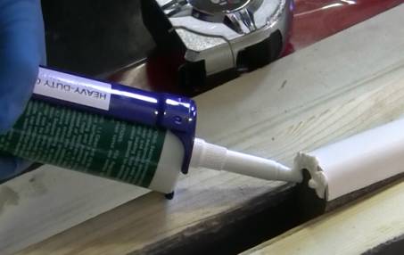
  - Lightly, quickly and thoroughly wipe the cured silicone facing with a lint free rag made damp with acetone or other solvent to remove the release agent.
- Apply Sealant to Edge of Silicone Facing
  - Apply thin bead of sealant to the end of silicone facing only. Use correct grade and color of sealant as supplied.
- Remove Adhesive-Release Paper & Install Joint
  - Peel off release paper to expose mounting adhesive on one face of material.
  - Feed material into joint, working sequentially in one direction starting at the bottom of the joint.
  - Always push material – DO NOT PULL IT – to prevent stretching (Start at bottom of wall and work up)
  - Recess 3/8 inch from wall surface.
  - Use a stiff-bladed putty knife to press the adhesive side of the material firmly against the substrate so that it will hold in place while it expands.
  - TIP: If material binds, lightly spray the putty knife and/or self-adhesive with water from the spray bottle to help it slide into joint gap.
  - If necessary, use small – approx. 3 inch—pieces of used hardboard packing as wedges to hold sections in place while they expand.
  - For changes in direction and plane see step 9
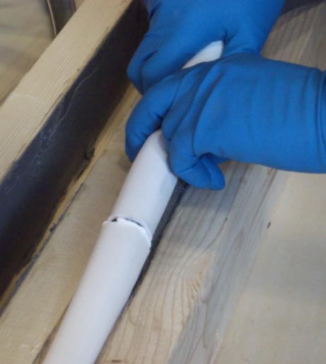
- Joining Successive Lengths
  - Insert first piece of material as described in step 6 but leave end protruding up and out of joint.
  - Place end of next section against end of first piece.1.
  - Leaving joint just made protruding from joint; insert the rest of this section of material into joint.
  - Finally push protruding joint section into joint 2.
  - Blend silicone bead applied in step 5 to silicone facing.
- Install Corner Beads
  - Corner beads are required with SES and PES
  - Wait until material is expanded fully against both sides of the joint.
  - Ensure that material and joint sides are dry if water spray was used to facilitate installation.
  - Gun a caulking bead where the sealant facing meets substrate.
  - Tool the corner bead firmly against the substrate and silicone facing.
- Direction Changes
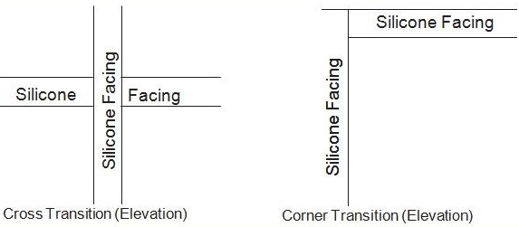 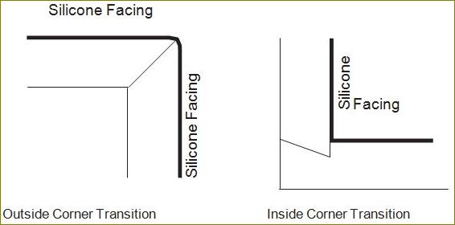
Operation
Expansion joints are designed and built for years of dependable service.
Maintenance
- Expansion Joints should be cleaned routinely.
- Exposed surfaces can be cleaned with a mild water-based cleaning solution. Wipe clean with a sponge or soft cloth.
- If any questions arise during the operation or maintenance of the products, please feel free to call our toll-free number for assistance, 1-800-547-2635 for technical support.

