January 1, 2019

RE: Roof Hatch Safety Grab Bar Product Change Notice

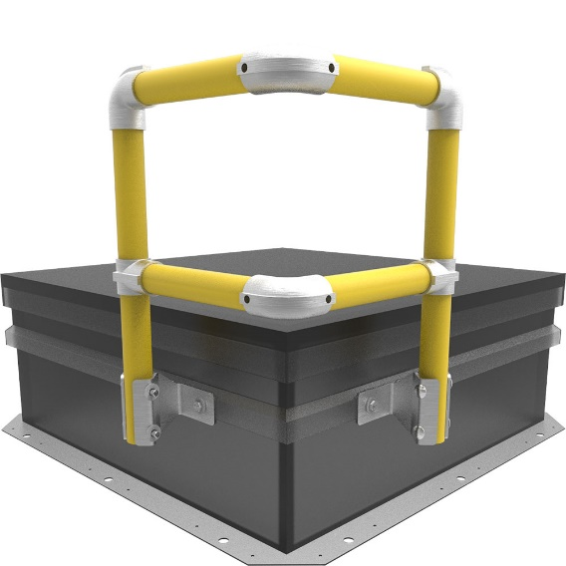
Nystrom announces the release of our updated Roof Hatch Safety Grab Bars to Safety Yellow Powder Coat.

Additions to the design:
  - New Aluminum rail and gate construction
  - Light weight design allows for easier and faster installation
  - Fits all brands of roof hatches that have a counterflash
  - Safety yellow powder coat finish standard
  - Still provides a non-penetrating attachment to the hatch via the counterflash
  - 5 year warranty
Specifications:
  - Rails / Posts – Aluminum pipe, 1-1/4 inch (31 mm) ID (1.66 inch OD) Schedule 40, 6061 T6 alloy
  - Fittings – Aluminum alloy 5052-H32
  - Mounting brackets – 3/16 inch steel, zinc plated
  - Hardware – Hex head bolts 3/8 inch – 16 by 34 inch zinc plated steel

MODEL | MATERIAL | FINISH
SGBAY | Aluminum | Powder Coat, Safety Yellow

The new aluminum safety rail and gate will begin shipping January 1, 2019. Please contact us at 1.800.547.2635 should you have any questions or concerns. We appreciate the opportunity to service you.

