Deep Pit, Stainless Frame IO&M
Entrance Mats and Grates
Frame model: SS-98SF

Prepare for Installation
- Locate the packing slip(s) and shop drawings.
- Verify that all products listed on the packing slip are included in the package.
- Check the products for damage. If products are damaged, report a freight claim immediately and leave the products in their packaging. If you sign for products without reporting damage you waive your right to a freight claim and will be responsible for their replacement cost.
- Read the instructions thoroughly before beginning installation.
- Stainless Steel grates are not recommended for exterior applications that experience cold, wintery climates. Snow and metal grates typically lead to slippery, walking surfaces.

Install the Frame
Properly installed frames are critical to the overall performance of the grate. Improperly installed frames may cause deflection in the grate and may possibly cause tripping hazards.

- The rough opening for the frame should be at least 3” deeper and 6” wider and longer than the frame. This provides clearance for the frame anchors and gives sufficient mortar strength to support the frame and grate assembly and allows room to maneuver the frame.
- Assemble the frame sections according to the shop drawings. If frames lengths are provided in sections, alignment screws are provided for connecting frame pieces together.
- Position the pre-cut and mitered frame members in the opening. Shim as necessary to level the frame to the final height of the finished floor surface.
- If any pre-drilled screws holes are located at the perimeter angle frame, grease the provided screws and thread into each of the drilled holes, allowing the screws to extend at least a 1/2” through the frame. Greasing the screws will prevent the concrete from bonding to the screw and allow the hold-down screws to be re-installed when the concrete has hardened.
- Pour cement mortar around edges of the frame and trowel in sufficient amount so that it will provide proper support for the frame and grate.
- Before the mortar sets, check the frame to make sure that it is plumb, that the members join at the correct angles, and that it is at the correct height. Also, check the measurements of the frame against the shop drawings in several locations to make sure that the sizes are correct. The grate will not fit if the frame is not installed exactly as indicated on the shop drawings. Use spreaders if necessary to hold the frame at the correct dimensions. Make sure the concrete supports the entire perimeter of the frame as shown on the shop drawings.
- Allow the concrete to cure.
- If applicable, Lay the pan sections on the bottom of the recess and caulk all seams. (All caulking to be provided by others.) Make any drain or trap connections. (All drain accessories provided by others)
- Attach the cross supports to the frames with the provided alignment screws. Fastening points between the cross supports and frames will be marked to indicate proper locations. Note that cross support locations are not interchangeable.
- Shim underneath cross supports as necessary with no more than two shims at the points where there are pre-punched screw holes. Excessive shimming will cause deflection in the grates. Anchor the supports by drilling through the shim and the insert and tap in the nylon expansion anchors provided. Note that the cross supports and framing structure must be flat and level within 1/8” over 10’ to ensure proper installation.

Install the Grate (Frame shipped together with grate)

- Clean the recess thoroughly. Note that debris will cause irregularities in the recess that will in turn cause the grate to rock or create a tripping hazard.
- Refer to the shop drawings and the marks on the sections to determine the correct location of each section. Note that the grate sections are not interchangeable.
- When ready to install the grates, apply the provided thread locker to each screw on the hold-down clips before returning grate to the recess.
- Set the grate sections in the proper locations and start threading all of the hold-down screws in the pre-drilled holes. Adjust the grates to create an even clearance around the edges and tighten all screws. Do not over-tighten the screws. There should still be some play in the hold-down straps. DO NOT attempt to pry apart the surface wires to access the screws. This will cause irreversible damage that is not covered by the warranty.
- Save the installation and maintenance instructions and include them with the closeout documentation for the owner and maintenance personnel.

Install the Grate (Frame shipped separately from grate)
It is recommended that the grate and frame be shipped as an assembly. When frames are shipped separately from the grates, it is critical that the installers follow instructions carefully. Please note that the labor involved will be significantly greater and Nystrom is not responsible for any additional labor charges incurred.

- Clean the recess thoroughly. Note that debris will cause irregularities in the recess that will in turn cause the grate to rock or create a tripping hazard.
- Refer to the shop drawings and the marks on the sections to determine the correct location of each section. Note that the grate sections are not interchangeable.
- Refer to the following hold-down illustration below while assembling hold-downs. Place the stainless steel screws in all of the hold-downs on the grate sections. Use the plastic washers provided to hold the screws in the lock-downs before putting the grates into the recess. DO NOT attempt to put the lock-down screws in by prying apart the surface wires and installing from the top of the grate. This will cause irreversible damage that is not covered by the warranty.

Illustration 1: Hold-downs must be assembled as illustrated.
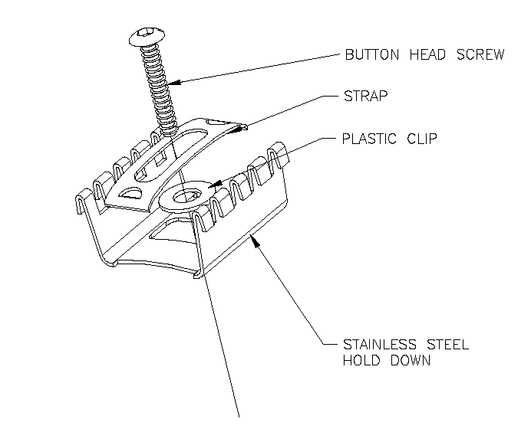

- Install the hold-down clips in the grate. They should be placed around the perimeter of each section and spaced at a maximum distance of 18” apart throughout each section and over the cross supports.
- To install the clips, place the clip in the frame at an angle and use a pry bar to insert the clip into the frame (See Figure 1). Press/Tap the clip into place using a flat head screwdriver so the fingers of the clips snap into the spaced between the surface wires. (See Figure 2)

Figure 1 | Figure 2
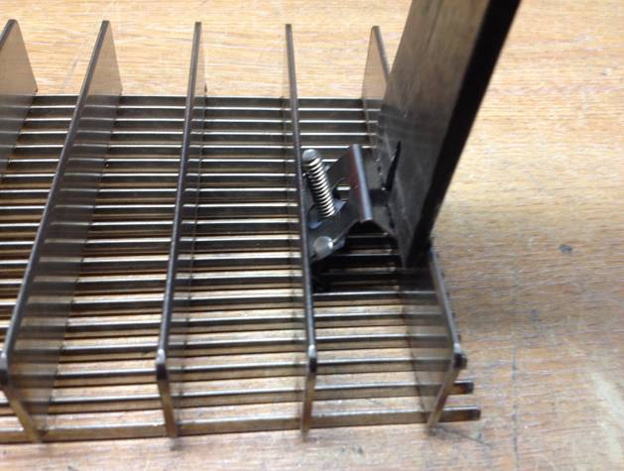 | 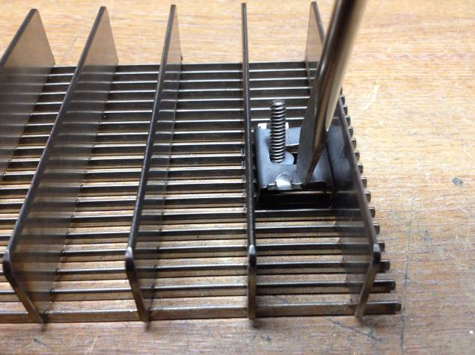

- Place the grate sections in position within the frame. Refer to the shop drawings for the proper location of the sections. Mark the locations of lock-down holes on the frames and cross supports.
- Remove the grating and set aside. Drill and tap the marked fastening points for the 10-24 machine screws provided.
- Before setting the grates back in the frames, apply the provided thread locker to each screw on the hold-down clips before returning grate to the recess.
- Set the grate sections back into the recess and start threading all of the hold-down screws in the embedded anchors. Adjust the grates to create an even clearance around the edges and tighten all screws. Do not over-tighten the screws. There should still be some play in the hold-down straps.
- Save the installation and maintenance instructions and include them with the closeout documentation for the owner and maintenance personnel.

Continued maintenance is critical to the long term safety and performance of the grate. Remove the grate and clean the recess periodically to prevent the surface from becoming uneven. Debris build up within the recess could lead to deflection in the grate and may possibly cause tripping hazards.

Clean the Treads
- Stainless steel grates
  - Surface wires can be cleaned with a non-ferrous cleaner such as 3M’s Scotch Brite™
  - Do not use steel wool or abrasive pads. The steel in these products will embed in the wires and subsequently rust

