Recess Mounted, Stainless Steel Corner Guard
Models: CGSR and CGTR

Important Notes:

- Locate the packing slip(s) and inspect all material for damages or missing parts. If products are damaged, notify the factory immediately and leave the products in their packaging. If products are signed and received without reporting damages, you waive your right to a freight claim and will be responsible for their replacement cost.
- Read the instructions thoroughly before beginning installation.
- Recess mounted, stainless steel corner guards should be mounted before the final layer of dry wall has been installed.

Installation:

- Partially remove protective covering from mounting flange of corner guard.
- Fasten corner guard to corner studs using drywall screws thru pre-drilled mounting holes.
- Install gypsum board over corner guard mounting flange. Finish drywall edges as necessary (drywall finish accessories by others).
- Remove the protective covering from the face of the corner guard and clean surfaces using a damp cloth if necessary.

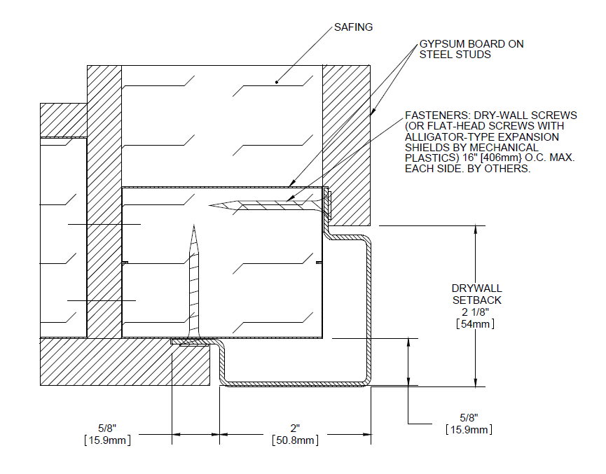
2” wings
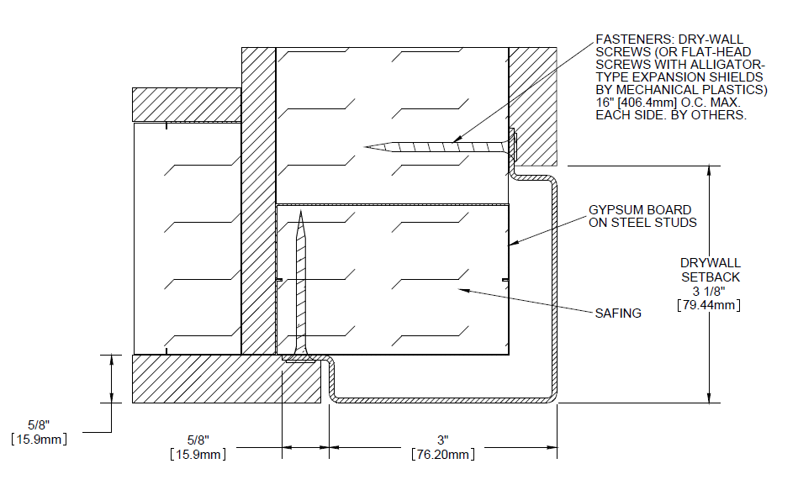
3” wings

Maintenance:

Pen marks, paint and graffiti generally wash off easily with mild soap and water. Be cautious with abrasive cleansers and scrub pads as they may scratch corner guards. Do not use steel wool or other metal scrub pads as fibers from the pads may stick to the corner guards and cause them to rust.

