Model(s): SS-38SF, SS-38SFD, SS-58SF,
SS-58SFD, SS-98SFLB, SS-98SDLB
Prepare for Installation
- Locate the packing slip(s) and shop drawings.
- Verify that all products listed on the packing slip are included in the package.
- Check the products for damage. If products are damaged, report a freight claim immediately and leave the products in their packaging. If you sign for products without reporting damage you waive your right to a freight claim and will be responsible for their replacement cost.
- Read the instructions thoroughly before beginning installation.
- Stainless Steel grilles are not recommended for exterior applications that experience cold, wintery climates. Snow and metal grilles typically lead to slippery, walking surfaces.
Install the Frame (standard – cast-in place frames)
A flat recess and accurately installed frames are critical to the overall performance of the mat / grille. Utilize a self-leveling compound (provide by others) if necessary to ensure a level recess,
- The rough opening for the frame should be at least 3 inches deeper and 1/8 inch wider than the overall frame dimensions. This provides clearance for the frame anchors and allows room to maneuver the frame.
- Position the pre-cut and mitered frame members in the opening. If frames lengths are provided in sections, frame pieces are to butt up against each other. No additional hardware is provided or required.
- Shim as necessary to level the frame to the final height of the finished floor surface.
- Pour cement mortar around the outside edges of the frame to be level with the unfinished floor and the center in sufficient quantity to be level with the inside lip of the frame.
- With a board that is slightly shorter than the inside of the frame, smooth and level the mortar. It is critical that the recess be absolutely level and at the correct height. The floor must be flat and level within 1/8 inch over 10 feet to ensure proper installation.
- Before the mortar sets, check the frame to make sure that it is plumb, that the members join at the correct angles, and that it is at the correct height. Also, check the measurements of the frame against the shop drawings in several locations to make sure that the sizes are correct. The grille will not fit if the frame is not installed exactly as indicated on the shop drawings. Use spreaders if necessary to hold the frame at the correct dimensions.
- Wait for cement to cure before proceeding.
- If applicable, lay the pan sections on the bottom of the recess and caulk all seams. (All caulking to be provided by others.) Make any drain or trap connections. (All drain accessories provided by others)
- Install plywood or other material in the recess to protect the edges of the frame until it is time to install the grilles. Wait to install the grilles until the building is ready for use.
Install the Frame (optional – drilled frames for mechanical fastening)
A flat recess and accurately installed frames are critical to the overall performance of the mat / grille. Utilize a self-leveling compound (provide by others) if necessary to ensure a level recess,
- Determine the correct depth of the recess. The outside of the frame must be flush with the finished floor surface. Make the recess the appropriate depth and slightly longer and wider than the frames to allow room to maneuver.
- Position the pre-cut and mitered frame members in the opening.
- Mark the pre-drilled fastening point locations on the floor. Drill 1/4 inch diameter by 1-1/2 inch deep holes in the floor for the anchors.
- Line the frame members up with the holes and securely fasten the frame to the floor with the provided anchors.
- Verify the frame to make sure that it is plumb, that corner conditions are joined at the correct angles, and that it is at the correct height. Also, check the measurements of the frame against the shop drawings in several locations to make sure that the sizes are correct. The grille will not fit if the frame is not installed as indicated on the shop drawings.
- Pour cement mortar around the outside edges of the frame to be level with the unfinished floor and the center in sufficient quantity to be level with the inside lip of the frame. Utilize a self-leveling compound (by others) if necessary to ensure a level recess. The floor must be flat and level with 1/8 inch over 10 feet to ensure proper installation.
- If applicable, lay the pan sections on the bottom of the recess and caulk all seams. (All caulking to be provided by others.) Make any drain or trap connections. (All drain accessories provided by others)
- When the cement has hardened, install plywood or other material in the recess to protect the edges of the frame until it is time to install the grilles. Wait to install the mats / grilles until the building is ready for use.

INSTALL THE DRAIN PAN (Optional)
- Use a caulk gun to apply adhesive to the recessed surface medium.
- Place pre-cut drain pan sheets into recess. Apply pressure to all areas of the pan to aid in bonding.
- Apply a silicone Caulk to all drain pan seams: Where pan meets frame and where pan sections abut.
Install the Grille
- Remove the plywood or other filler from the recess and clean the recess thoroughly. Note that debris will cause irregularities in the recess that will in turn cause the grille to rock or create a tripping hazard.
- Refer to the shop drawings and the marks on the sections to determine the correct location of each section. Note that the grille sections are not interchangeable.
- Refer to the following hold-down illustration below while assembling hold-downs. Place the stainless-steel screws in all of the hold-downs on the grille sections. Use the plastic washers provided to hold the screws in the lock-downs before putting the grilles into the recess. DO NOT attempt to put the lock-down screws in by prying apart the surface wires and installing from the top of the grille. This will cause irreversible damage that is not covered by the warranty.
Illustration 1: Hold-downs must be assembled as illustrated.

- Install the hold-down clips in the grille. They should be placed around the perimeter of each section and spaced at a maximum distance of 18 inches apart throughout each section and over the entire grating.
- To install the clips, place the clip in the frame at an angle and use a pry bar to insert the clip into the frame (See Figure 1). Press/Tap the clip into place using a flat head screwdriver so the fingers of the clips snap into the spaced between the surface wires. (See Figure 2)
Figure 1 | Figure 2
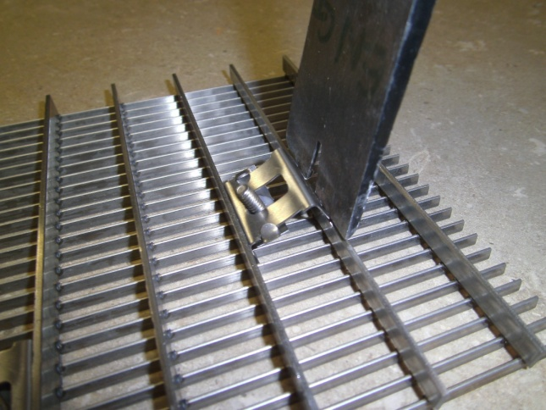 | 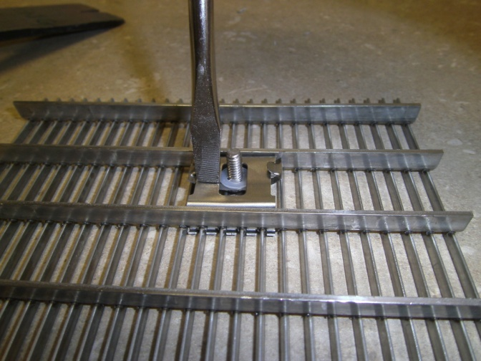
- Place the grille sections in position within the recess. Refer to the shop drawings for the proper location of the sections. Mark the locations of lock-down holes in the concrete pit.
- Remove the grating and set aside. Drill 3/8 inch diameter by 5/8 inch deep holes into concrete at the marked locations for anchors provided.
- Clear the hole of all debris.
- Insert the threaded cone end of the anchor into the hole. Insert the provided setting tool into the anchor and hit the setting tool with a hammer until the anchor is set.
- Set the grille sections back into the recess and start threading all hold-down screws in the embedded anchors. Adjust the grilles to create an even clearance around the edges and tighten all screws. Do not over-tighten the screws. There should still be some play in the hold-down straps.
- Save the installation and maintenance instructions and include them with the closeout documentation for the owner and maintenance personnel.
maintenance
Continued maintenance is critical to the long-term safety and performance of the grille. Remove the grille and clean the recess periodically to prevent the surface from becoming uneven. Debris build up within the recess could lead to deflection in the grille and may possibly cause tripping hazards.
The type and schedule of maintenance of your grille or mat will depend upon location and amount of traffic. See the outline below for cleaning instructions for the variety of tread insert materials.
UltraSorb®
- A good heavy-duty vacuum cleaner with a rotating brush is the most effective way to routinely clean the carpet in your entrance grille or mat. By vibrating the fibers, this type of vacuum not only cleans the surface of the carpet, but also removes soil that is imbedded into the pile. The rotating brush aids in keeping the pile upright for longer lasting beauty.
- The heaviest traffic areas should be vacuumed daily and the light traffic areas as infrequently as weekly.
- Carpet should be deep cleaned with a hot water extraction cleaner once per month or when vacuuming will no longer remove the soil. This may be monthly, quarterly, or longer, depending upon soil and traffic conditions.
- Inspect the grille or mat regularly for spots and stains, to reduce the possibility of them becoming permanent.
- Removing Spots
  - If the spot is semi-solid, scrape with a spoon or spatula and then blot with a damp sponge. Work from the edge of the spot to the center. This will keep the stain from spreading. If this procedure does not work, use a spot remover.
  - We recommend a dry system because it reduces solid build-up won’t leave floors wet and slippery, and there is no risk in damaging the carpet from dye bleeding. For most spills such as coffee, tea, pet stains, etc., a dry soil extractor works best.
  - Wet cleaning methods, including aerosols, foams, hot water extraction, or shampoo will work, but sometimes they leave sticky detergent residue that will accelerate soil build-up.
  - For oily stains such as tar, grease, paint, etc., a non-flammable dry cleaning solvent works best. Be extremely careful when using dry cleaning solvent. Take care to check for color fastness before cleaning the entire surface. Put a few drops of stain remover in an inconspicuous area and press the area with a clean cloth for ten seconds. If the color fades or changes, discontinue use.
Rugged Scrub®
- The most effective way to clean the treads is with a garden hose or high-pressure washer, as necessary. The treads can withstand pressure of up to 1,000 pounds per square inch. A good heavy-duty vacuum cleaner with a rotating brush will remove most dirt from your Rugged Scrub® treads during routine daily cleaning.
- Do not use petroleum-based products to clean Rugged Scrub®. These types of solvents will damage or dissolve the treads.

Stainless Steel Grilles
- Surface wires can be cleaned with a non-ferrous cleaner such as 3M’s Scotch Brite™
- Do not use steel wool or abrasive pads. The steel in these products will embed in the wires and subsequently rust
If carpet tread inserts become damaged, replacement strips are available at Nystrom.com

