Stainless Steel Crash Rail
Models: CRSS4, CRSS55, CRSS55-VG

Important Notes:

- Locate the packing slip(s) and inspect all material for damages or missing parts. If products are damaged, notify the factory immediately and leave the products in their packaging. If products are signed and received without reporting damages, you waive your right to a freight claim and will be responsible for their replacement cost.
- Read the instructions thoroughly before beginning installation.
- Stainless Steel covers are shipped in stock lengths
- Carefully measure and mark all holes to be drilled to achieve a properly supported and level installation.

Measure
- Measure and mark the top of crash rail and rail system centerline on wall or partition per detail sheet.
- Measure and mark end points of crash rail on the centerline.
- Measure and cut retainer and cover sections to length for each crash rail segment. Offsetting the cover joints from the wood retainer joints is recommended for a more uniform appearance. Verify that cut lengths conform exactly to lengths marked on wall or partition. If the retainer lengths are longer than the stainless steel crash rail cover lengths, the end caps will not pull tight against the crash rail ends.

Cutting Medium-Gauge Steel
- It is recommended that the Crash Rail be cut with a band saw or chop saw with the appropriate metal cutting blade. If this is not available, see manual cutting instructions below.
- Manual Cutting:
  - Cut steel with an electric jigsaw with a metal cutting blade or with a hacksaw.
  - Clamp your steel to a work bench or sawhorse. For thinner gauge metal you may want to use a piece of scrap wood as backing so that the stainless steel sheet does not bend during cutting.
  - Mark a line along which you wish to make your cut with a permanent marker or scribe.
  - Put on a pair of safety glasses, leather gloves and earplugs. Fit your metal cutting blade into your hacksaw or jigsaw. Line the blade up with the edge of the steel sheet and activate the electric saw blade. The blade may heat up quickly, which will cause it to dull, so work slowly and take frequent breaks from cutting. Keep hands and fingers out of the path of the saw blade at all times and watch for flying debris. If the saw blade gets stuck at any point, immediately disengage the power and realign the blade to prevent damage to the saw.
  - Sand the rough edges and burs with sandpaper after you have allowed the piece to cool.

Installation
- Measure and mark centerline for attachment fasteners on retainer sections
- Measure and mark vertical centerlines for retainer attachment fasteners on this centerline. Retainer fasteners should be no more than 32” (812.8mm) on center and within 3” (76.2mm) of the end of each retainer segment.
- Measure and market vertical centerlines for attachment fasteners on the rail system centerline on wall or partition
- Drill fastener holes in wall or partition. For most drywall applications we recommend ¼” toggle bolts. For most masonry applications we recommend ¼” screws and plug anchors.
- Drill fastener holes in retainer lengths to align with holes on wall or partition. Makes holes as small as possible, allowing for fasteners.
- Secure retainers to wall or partition. If splices were necessary, make sure adjoining sections are aligned exactly to facilitate mounting stainless covers.
- Install covers; offsetting the cover joints from the wood retainer joints is recommended for a more uniform appearance.
- Install endplates. Hold endplates in position taking care to allow equal overlap of retainer at top, bottom and front face of cover. Mark holds for attachment screws and drill pilot holes for the #10x2” stainless steel oval head screws. Attach endplates.
- Remove protection covering from over and endplates and clean surfaces as necessary.

Maintenance:

Pen marks, paint and graffiti generally wash off easily with mild soap and water. Be cautious with abrasive cleansers and scrub pads as they may scratch the material. Do not use steel wool or other metal scrub pads as fibers from the pads may stick to the material and cause them to rust.

Model #CRSS4  Fastener Heights | 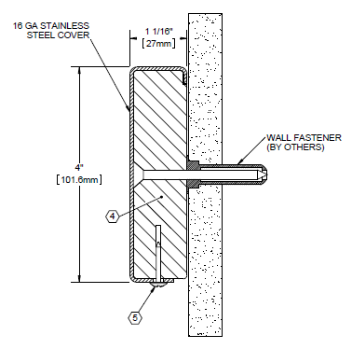 | 