Model(s): SVX

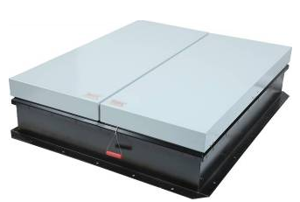
Overview
Acoustical smoke vents are designed to open automatically to provide emergency smoke and heat ventilation. Prompt venting in case of fire is essential for the safe evacuation of occupants and for effective fire-fighting conditions within a building. The smoke vent is not intended for use as general-purpose building ventilation devices. International Building Code (IBC) requires smoke venting in a variety of applications including; Section 410 for stages and platforms, Section 910 for factory and storage occupancies.
Acoustical smoke vents are primarily used in theaters and performing arts centers because they block the intrusion of exterior environmental noise. Acoustical smoke vents provide both sound control and thermal performance The SVX is sound rated STC48/OITC 36 and the SVY is rated STC50/OITC 39. The STC50 provides ultimate sound control and a total R-14 thermal resistance for superior thermal performance. The STC50 sound rated series meets International Building Code IBC 1207 sound transmission class requirements and is used in high end theater applications as well as in building applications where condensation is a concern.
Sound transmission is tested by an independent lab accredited by the U.S. Department of Commerce and the National Institute of Standards and Technology for conducting official acoustical test procedures for sound transmission class (STC) and Outdoor-Indoor Transmission Class (OITC) according to the following tests
- ASTM E90 Laboratory Measurement of Airborne Sound Transmission of Building Partitions
- ASTM E1332 Standard Classification for Determination of Outdoor-Indoor Transmission Class
Installation
- Ensure that the roof mounting surface is level to avoid twisting of the smoke vent base. It is essential that the vents are installed level and square for the door to make a proper seal. Place the smoke vent over the existing opening in the roof that has been prepared with appropriate roofing membrane, if applicable.
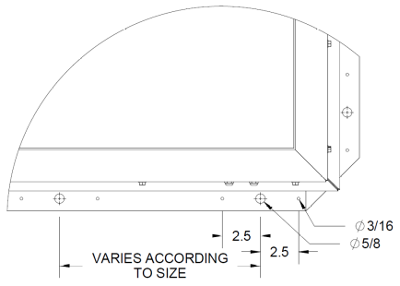
  - The roof rough opening dimensions are equal to the vent dimensions as measure from the inside curb to inside curb. For example, a 48 inch by 96 inch smoke vent will have a roof rough opening of 48 inches by 96 inches.
- The smoke vent single wall curb flange comes with two (2) types of mounting holes to accommodate multiple fastening methods practiced and accepted at a local level.
  - Mark the pre-drilled 5/8 inch diameter holes from the mounting flange through to the roof deck or a concrete curb. Drill roof deck or concrete curb for installation of anchors or other fasteners (provided by others). Bolt or otherwise fasten curb flange to roof deck using 3/8” diameter bolts, screws, or anchors as detailed below for wood, steel and concrete mounting applications.
    - Factory Mutual (FM4430) labeled smoke vents must use one of these methods.
    - These installations are also recommended for high velocity hurricane zones typical in Florida, such as Miami-Dade County.
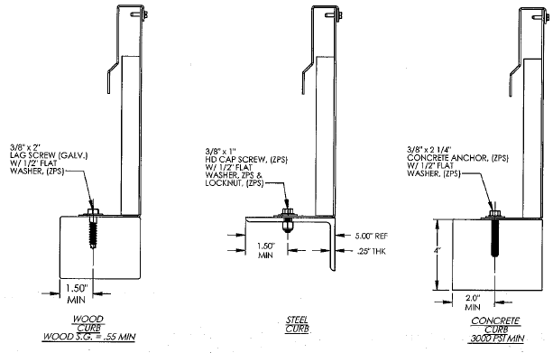
  - Mark the pre-drilled 3/16 inch diameter holes from the mounting flange through to the roof deck, typically into a built up wood fame curb. Fasten roof hatch curb flange to framing using roofing nailers and/or screws, recommended size 3/16 inch by 1-1/4 inch long.
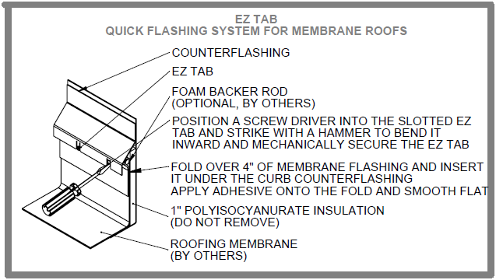
- Install roofing material up to and around the curb, up under the counterflashing, using appropriate roofing material and locally accepted processes. Do not remove curb insulation. Lay membrane flashing up onto curb insulation. Press up under counterflashing using foam backer rod (by others). Apply adhesive to fully secure membrane in position. Ensure all joints are fully sealed to provide a weather tight seal. Bend EZ tabs to mechanically secure, using a screwdriver or similar tool.
- Conduct an acceptance performance test and inspection of all smoke vents immediately following installation to establish that all operating mechanism function properly.
Operation
Vents are designed and built for years of dependable service. Smoke vents do not require field painting. If field painted, all component parts must be masked, especially moving parts and all labels. Field painted component parts will void the warranty.
- Latch: Positive hold rotary latches are designed to hold the covers closed.
- Gas Spring/Damper: Provides force to automatically open covers.
- Hold Open Arm: Automatic hold open arm engages to keep doors locked open when released. Pull the red vinyl grip handle forward to disengage, while safely closing the door(s).
- Link: Fusible melt out links are replaceable (SV-KIT-LINK-165, SV-KIT-LINK-280, etc)
- Smoke vents are designed to open manually via pull handles located on the exterior and interior of the smoke vent. The internal pull cable can be extended and rigged down to the floor level to assist with emergency vent opening.
- Smoke vents are designed to open thermally when a UL listed fusible link melts at temperatures of 165°F, 212°F, 280°F, 350°F, 360°F, 370°F, 386°F or 450°F. Fusible links are easily accessed from the roof for replacement, as detailed.
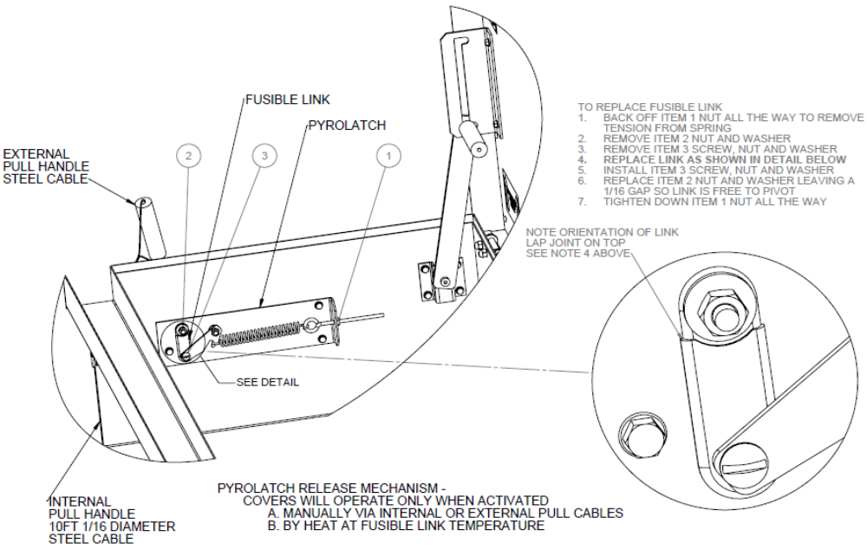
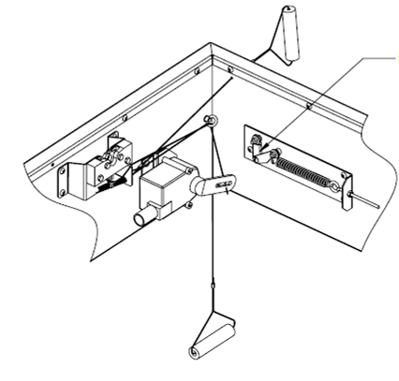
- OPTION: Electrical Belimo Actuator
Smoke vents can include an option to open electrically with a low voltage (24VDC/AC) or High Voltage (110VAC/220VAC) at 2.5Watt signal. The electrical option is ideal to coordinate vent opening with a fire alarm, smoke detector or sprinkler system.
Belimo Actuator
Smoke vent covers are closed manually from the exterior roof top level. Make sure to disengage the hold open arm prior to closing the doors.

Acceptance Testing
An acceptance performance test and inspection of all vents shall be conducted immediately following installation to establish that all operating mechanism functions properly. Vents should be operated in accordance with the authority having jurisdiction (AHJ).

Test for proper operation using one or more of the following methods.
- Manual pull handles: Pull the manual pull handle from the exterior of the smoke vent. Pull the internal manual pull handle, if it has been routed down to the floor level.
- Fusible link: Melt the fusible link from the inside at the smoke vent level using a hand-held propane tank torch. Make sure to have replaceable fusible links on hand to reset the latch and close the doors. An alternative method is to remove the fusible link to simulate melting to verify that the smoke vent would indeed open.
- Optional electrical Belimo actuator: Send an electrical signal from the fire alarm, push button control, or other to validate electrical fire system performance.
Maintenance
- Vents should be manually operated once a year to inspect, maintain and replace components as necessary.
- Inspect fusible links for evidence of corrosion, stress/strain or build up. Clean or replace as required.
- Non-moving parts can be cleaned with a mild soap or dishwashing detergent and water solution.
- Gaskets can be cleaned with a clean, damp, lint-free cloth. Do not apply mineral oils, vinyl dressings, or other lubricants to the gasket as they can cause the gasket to break down over time.
Fusible link ambient temperature rating
The fusible link should be specified with a temperature rating greater than the maximum ambient exposure temperature that will be seen at the installation. For example, an “ordinary” fusible link rated at 165°F has a maximum ambient exposure temperature rating of 100°F. If this fusible link is routinely exposed to ambient temperatures over 100°F, it is liable to separate. Select a fusible link rated at 212°F (or greater) for this type of application. See table below to find a fusible link temperature range compatible with an expected or measured ambient temperature. This is in accordance
with UL guidelines.
Temperature classification | Temperature Ratings |  | Maximum Ambient Temperature
Temperature classification | Degrees F | Degrees C | Degrees F | Degrees C
Low  Ordinary  Intermediate  High  Extra High  Very Extra High  Ultra High | 125 – 130  135 – 170  175 – 225  250 – 300  325 – 375  400 – 475  500 - 575 | 51 – 54  57 – 77  79 – 107  121 – 149  163 – 191  204 – 246  260 - 302 | 90  100  150  225  300  375  475 | 32  38  66  107  149  191  246
If there are any questions during the installation, operation or maintenance of smoke vents, please call toll-free 1-800-547-2635.
Option: Winch Overview
Smoke vents with manual winches provide remote opening and closing of the smoke vents from a remote location, such as the theater catwalk or floor level. The design consists of a lower winch that both opens and closes the smoke vents. The upper winch is designed to facilitate cable resetting after the vent covers open when activated thermally with a fusible link, manually with the external pull cable or electrically with and optional 2.5W Belimo actuator when energized 24V or 110V. Reset at the roof level.

Manual Winch Operation
Open Smoke Vent with Manual Winch
- Pull manual release cable to release the rotary latch in the smoke vent
- Unwind manual winch to fully open smoke vent doors
Close Smoke Vent with Manual Winch
- Move lever to the downward position to disengage the locking hold open arm
- Wind the manual winch until the vent rotary latches engage to secure covers closed
- Return the lever to the upward position

Reset at Roof Level
- Feed out a minimum of 14ft of cable at lower winch to create slack.
- At upper winch remove spent fusible link from the system by removing the retaining lock nuts. Reseat the spring attached to the lever arm to the winch housing. Pull the lever arm up, bring the two screws close enough to set the new fusible link in place and secure with the retaining lock nuts. (Only if thermally released).
- Flip the ratchet at upper winch up to the engaged position.
- Wind upper winch until the cable in taught.
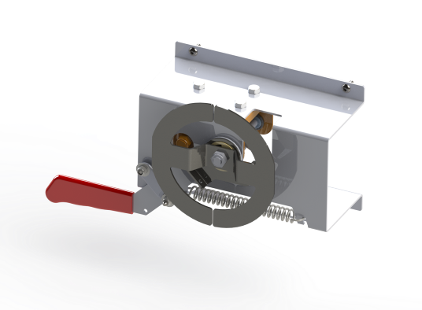
- The thermal release is now reset and the vent can be winched closed by lower winch.

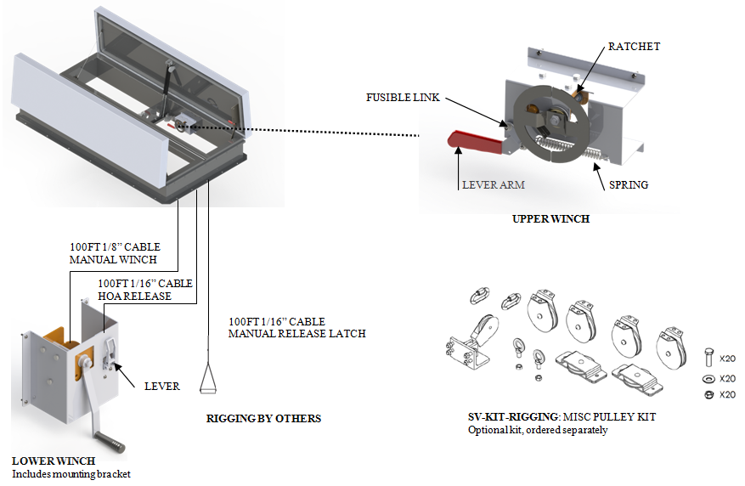

Installation Instructions for Manual Winch
- Once the smoke vent has been roofed in and is fully installed the Manual Winch option can be set up to operate the doors to open and close.
- Determine the desired location for the floor level winch (shipped loose) and mount it to a suitable structure.
- Rig the 1/8 inch manual winch cable, 1/16 inch HOA cable, and 1/16 inch manual release cable down to the floor level winch. (All three cables should be coiled on the interior side of the unit).
- Attach and wind the 1/8 inch cable taught onto the floor level winch.
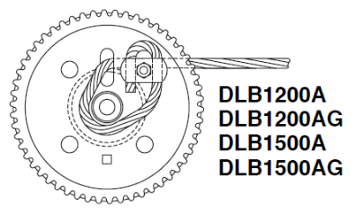
Figure A – Cable Termination for Floor Winch
- Open the smoke vent by pulling the interior manual release (now rigged to a location near the floor winch) to disengage the latch and unwind the manual winch until the smoke vent doors are fully open.
- Place the lever on the floor winch in the downward position and tie the 1/16 inch HOA cable to the HOA tie off point of the lever. Ensure the cable is taught. (IMPORTANT: this cable is require to disengage the hold open arms, if it is not installed prior to closing the smoke vent with the manual winch the unit will be damaged during the operation, UL 793 requires the inclusion of the hold open arms as the doors are required to lock into the open position)
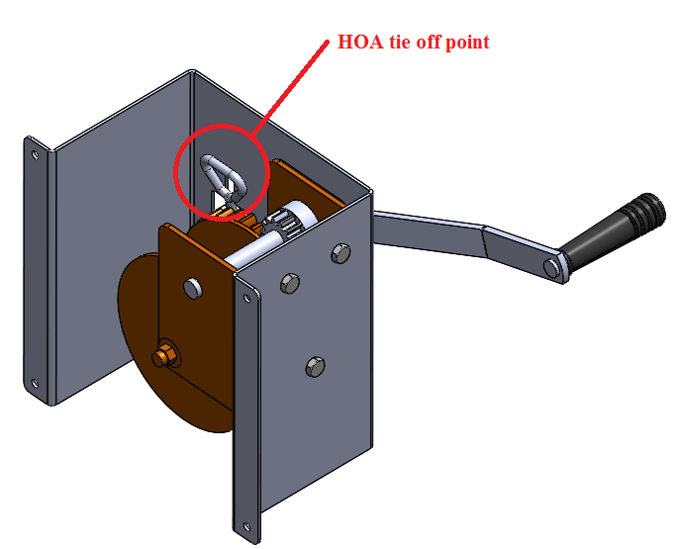
Figure B – HOA Tie-off Point

- To ensure the HOA cable was correctly fastened, with the lever in the downward position, wind the winch slowly to begin closing the doors. If the doors close, the HOA cable has been properly secured. If the doors only close slightly and the force required to wind the winch increase greatly the HOA cable has not been secured tight enough and the operator should cease winding as continued operation could result in damage to the unit. If the HOA cable has not been secured tight enough, detach and reattach it tighter than it was previously.
- Once the HOA cable has been confirmed to be securely fashioned the smoke vent can be winched close and the installation of the Manual Winch option is complete.
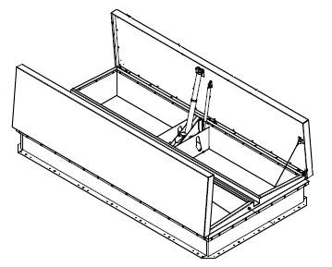
Option: Linear Actuator Overview
Smoke vents with linear actuators are designed to conveniently open and close smoke vents remotely with a push button controller. The system is comprised of linear actuators (one per cover), a control box mounted to the inside of the smoke vent curb, a 2 position (open, close) push button station and door position sensors.
These smoke vents are also designed to open automatically without power in the event of a fire emergency. Smoke vents open thermally when heat parts a fusible link and they also open manually with both internal and external manual pull handles.
Linear Actuator Smoke Vent Modes of Operation
Open Smoke Vents
- Manual*
  - Pull manual release cable (exterior or interior) to release the actuator latch and open vents
- Thermal*
  - Fusible link melts to release the actuator latch and open vents. A new link is required.
*If smoke vent is opened manually or thermally, the linear actuator must be reset and securely re-latched to curb. This is accomplished by electrically opening to fully extend the linear actuator so that the rotary latch engages.
- Electrical Open with Controller:
- Push OPEN button on controller, continuously hold until door limit stops motion
- Rotate the toggle switch to other door (A or B)
- Push OPEN button on controller, continuously hold until door limit stops motion
- Electrical Open with signal (by others)
- Wire a 24VDC signal from a fire alarm, smoke detector, etc. into the control box at the smoke vent level.
Close Smoke Vent
- Electrical Close:
- Push CLOSE button on controller, continuously hold until door limit stops motion
- Rotate the toggle switch to other door (A or B)
- Push CLOSE button on controller, continuously hold until door limit stops motion
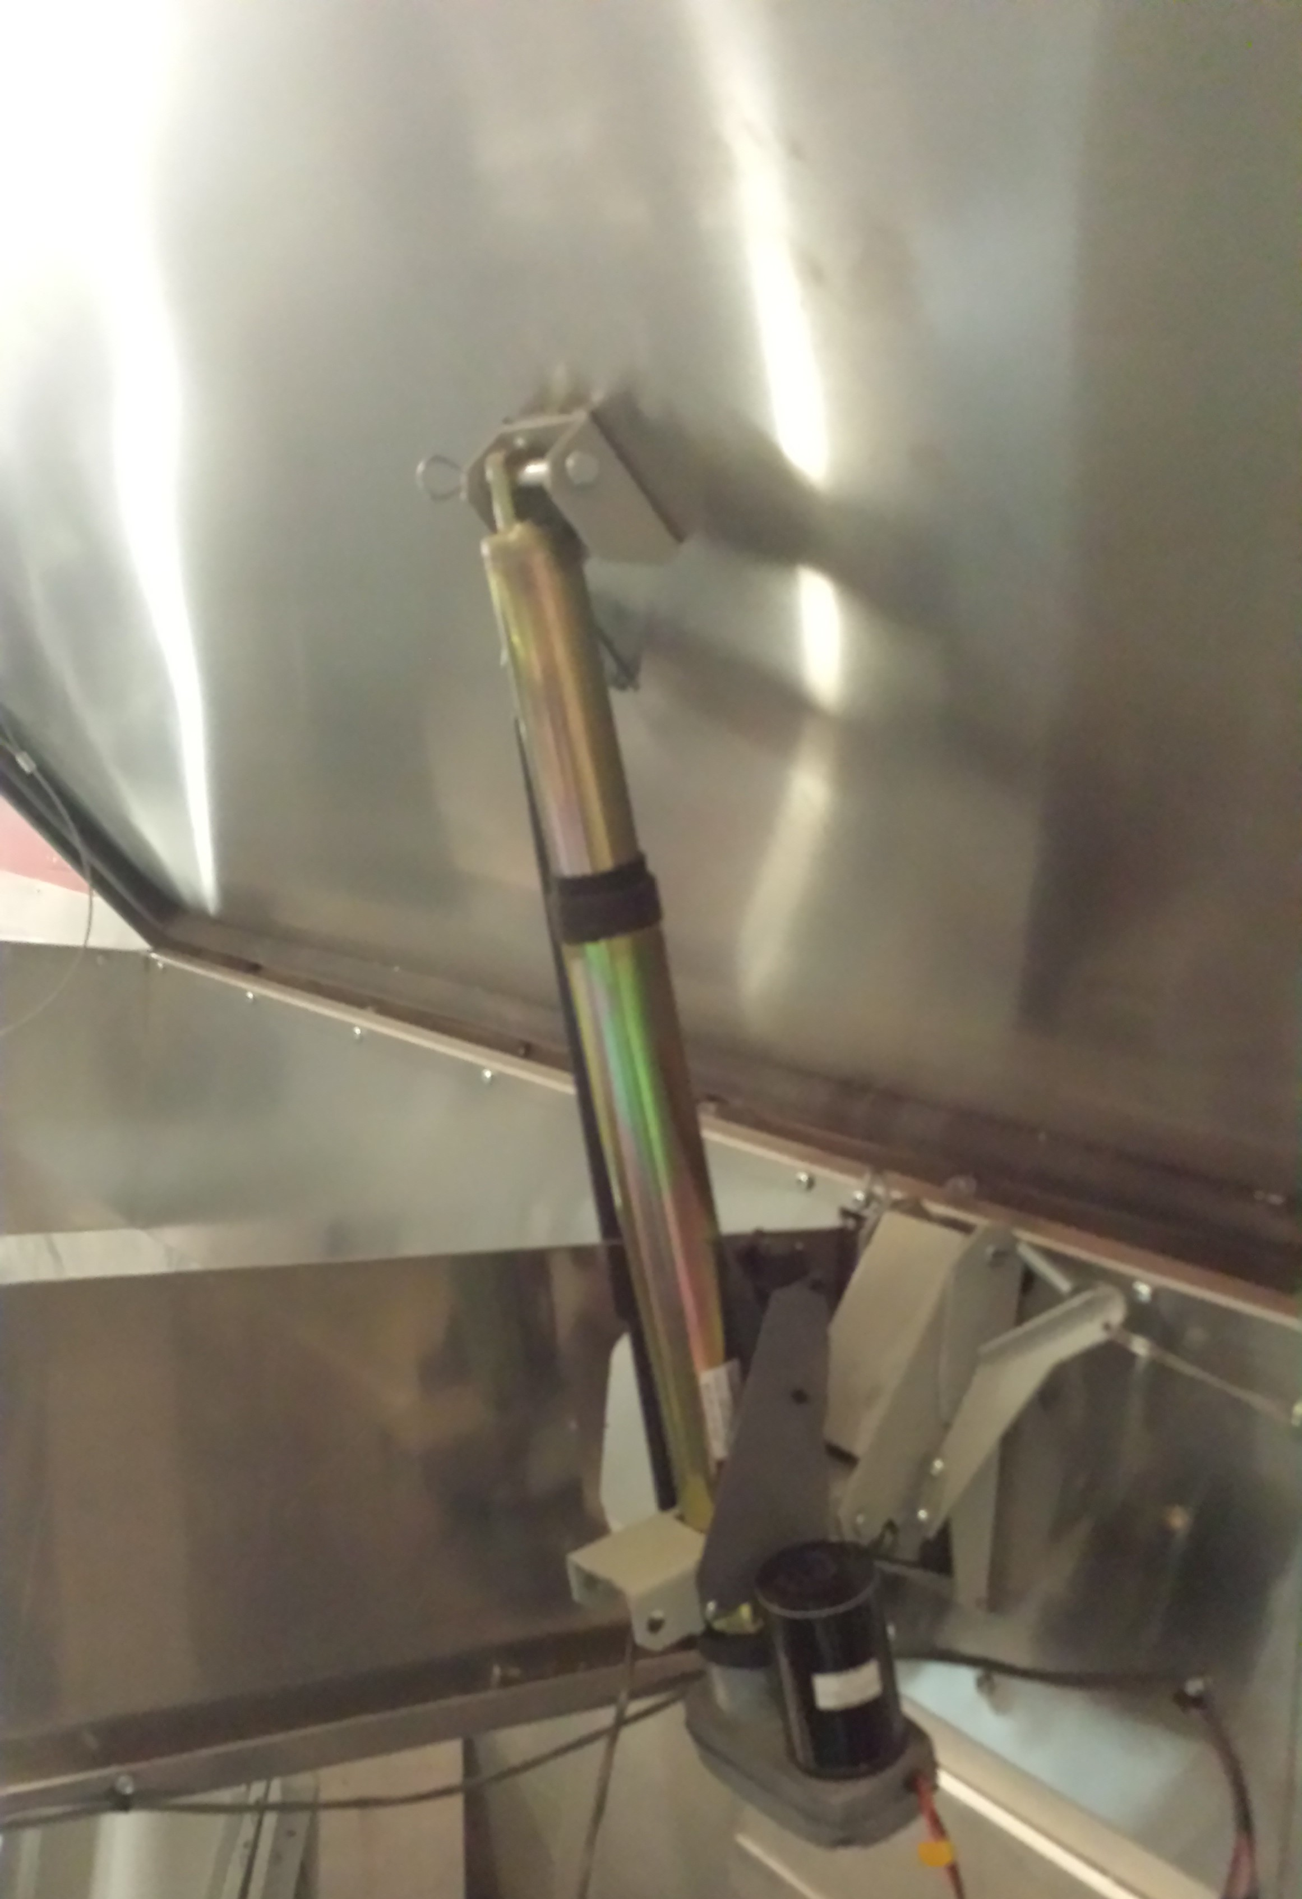

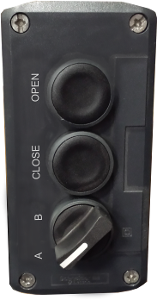
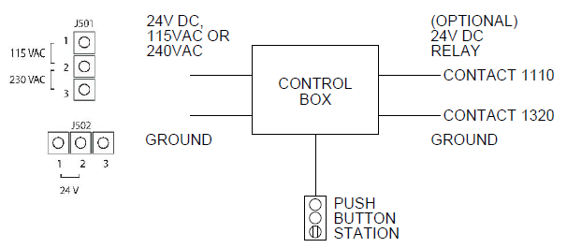

Push Button Station
Linear Actuator

User Operation | Execution | Reset?
Open using push button station | User sets toggle switch to position A and depresses the open button until door A fully opens, user then switches the toggle to position B and depresses the open button until door B fully opens. | no
Close using push button station | User sets toggle switch to position A and depresses the close button until door A fully closes, user then switches the toggle to position B and depresses the close button until door B fully closes. | no
Open using interior manual pull * | User pulls the interior manual pull | yes
Open using exterior manual pull * | User pulls the exterior manual pull | yes
Thermally * | Fusible link melts at listed temperature (160-520F) | yes
Open with 24V Signal (fire alarm) | Optional signal sent from fire alarm, smoke detector, etc by others | no
Reset | Push and hold the Open button on the control button station until the actuators back into the rotary latches. | n/a
* EMERGENCY OPERATION, releasing the actuator from the rotary latched pivot point
Input | Operation
User has toggle to actuator A. Presses and holds the open button. | Controller checks to ensure the open position limit switch for door A is not closed, if not the controller will drive the actuator to extend until the user releases the open button or the open position limit switch for door A closes
User has toggle to actuator B. Presses and holds the open button. | Controller checks to ensure the open position limit switch for door B is not closed, if not the controller will drive the actuator to extend until the user releases the open button or the open position limit switch for door B closes
User has toggle to actuator A. Presses and holds the close button. | Controller checks to ensure the close position limit switch for door A is not closed, if not the controller will drive the actuator to collapse until the user releases the close button or the close position limit switch for door A closes
User has toggle to actuator B. Presses and holds the close button. | Controller checks to ensure the close position limit switch for door B is not closed, if not the controller will drive the actuator to collapse until the user releases the close button or the close position limit switch for door B closes
Fire alarm tie-in sends a constant signal to the 24V relay in control box when the fire alarm is tripped | The controller will drive actuator A until the open position limit switch for door A closes or until the timer finishes, it will then drive actuator B until the open position limit switch for door B closes

