Model(s): EJ ES

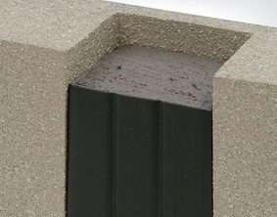
Preparation
- Locate the packing slip(s) and shop drawings.
- Verify that all products listed on the packing slip are included in the package.
- Check the products for damage. If products are damaged, report a freight claim immediately and leave the products in their packaging. If you sign for products without reporting damage you waive your right to a freight claim and will be responsible for their replacement cost.
- Read the instructions thoroughly before beginning installation.

Tools List
- Tape Measure
- Serrated Edge Knives
- Acetone, lint free rags & clean paint bucket
- Caulking Gun and Caulk Knives
- Spray Bottle Filled with Water
Pre-Installation
- Ensure joint faces are parallel and have sufficient depth to receive the full depth of the size(s) of ES product being installed plus at least ¼ inch (6mm) for the application of corner beads.
- Repair spalled irregular or unsound joint surfaces using accepted industry practices for repair of the substrates in question. Remove protruding roughness to ensure joint sides are smooth.
- Remove all residues of old sealants. Wire brush or angle grind, if necessary, to clean sides.
- Wipe joint faces with lint-free rags dipped in solvent or other agent suitable for use on the substrates in question to ensure joint sides are free of dust, previous sealant, oils, grease, etc.
- Ensure joint sides are dry of solvent or cleaning agent prior to installation.
A
A
Installation
- Find and Open Correct Box
  - Material has been supplied to your mean-temperature field measurement of joint widths. Joint widths for material supplied are marked at the end of each box.
    - Find correct box and open it.
    - Compare material width marked on each stick against joint width
    - Actual material width measured between hardboard will be slightly less than indicated joint width. If unsure of correct material selection, consult Nystrom.
- Wipe Release Agent off Silicone Facing
  - For packaging and protection reasons, the silicone facing is coated in the factory with a release agent.
  - Prior to installation, this agent must be wiped off using a solvent in order for the fillet beads described in step 6 to adhere to the silicone facing and to avoid contamination of the substrate at this point.
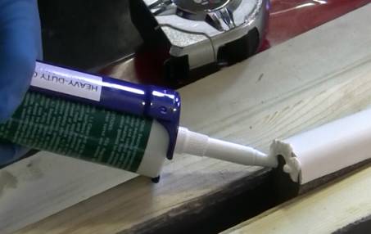
  - Lightly, quickly and thoroughly wipe the cured silicone facing with a lint free rag made damp with acetone or other solvent to remove the release agent.
- Apply Sealant to Edge of Silicone Facing
  - Apply thin bead of sealant to the end of silicone facing only. Use correct grade and color of sealant as supplied.

- Install Seal into Joint
  - Place a bead of silicone on each side of the joint opening, roughly 1 inch down from the surface.
  - Feed material into joint, compressing and working sequentially in one direction starting at the bottom of the joint.
  - Always push material – DO NOT PULL IT – to prevent stretching. (Start at bottom of wall and work up).
  - Recess 3/8 inch from wall surface.
  - Use a stiff-bladed putty knife to press the adhesive side of the material firmly against the substrate so that it will hold in place while it expands.
  - For changes in direction and plane see step 6

- Joining Successive Lengths
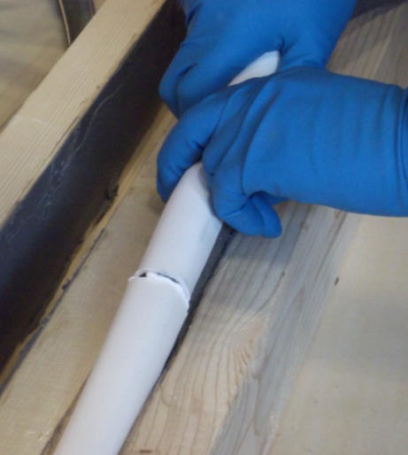
  - Insert first piece of material as described in step 4 but leave end protruding up and out of joint.
  - Place end of next section against end of first piece.
  - Leaving joint just made protruding from joint; insert the rest of this section of material into joint.
  - Finally push protruding joint section into joint 2.
  - Blend silicone bead applied in step 3 to silicone facing.
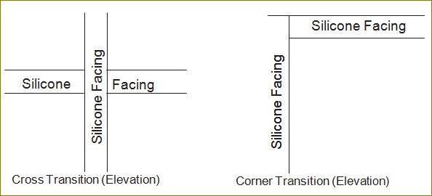
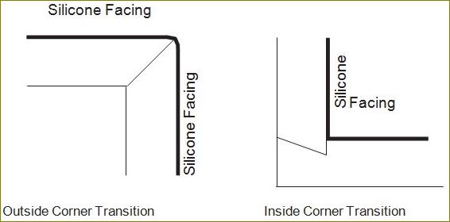
- Direction Changes

Operation
Expansion joints are designed and built for years of dependable service.
Maintenance
- Expansion Joints should be cleaned routinely.
- Exposed surfaces can be cleaned with a mild water-based cleaning solution. Wipe clean with a sponge or soft cloth.
- If any questions arise during the operation or maintenance of the products, please feel free to call our toll-free number for assistance, 1-800-547-2635 for technical support.

