Drainable Floor Door, H20, HS20
Drainable Large Equipment Hatch, H20, HS20
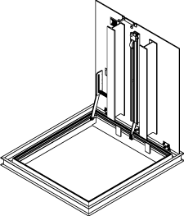
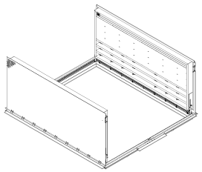
INSTALLATION, OPERATION + MAINTENANCE MANUAL
Model(s): FDDH, FDDS, FDOH, FDOS

Table of Contents

Table of Contents
General Description 2
Installation 3
Operation 7
Maintenance 8
Parts List 9
Standard Warranty 10
Factory Assistance 11

Copyright
2019 by Nystrom, Inc. All rights reserved.

This document contains proprietary information. No part of this document may be reproduced without the prior written consent of Nystrom, Inc.

Note
The information in this document is subject to change without notice.

General Safety Precautions
Improper selection, installation, or use can cause personal injury or property damage. It is solely the responsibility of the user, through its own analysis to select products suitable for their specific application requirements, ensure they are properly maintained, and limit their use to its intended purpose.

Follow proper local, state and federal regulations for proper installation and operation requirements.

General Description
Floor Door products are designed and built for years of service and weather tight access for personnel and equipment. The following are general instructions for installing, operating and maintaining floor door products. These are recommended general guidelines only. Locally accepted installation, sealing practices and procedures should be followed to ensure the ultimate weather-ability of floor doors installed into various types of flooring systems.

Preparation
Please read the complete instructions carefully before beginning any work.
Special care is required when handling and installing floor doors. Please make sure that all framework and doors are supported during transport and installation to insure against bending or racking of the floor door.
Please inspect and set aside parts for later installation

Installation

- Slam latch keys
- Plug for keyhole

Storage
- Floor doors are shipped with the intent for installation within 30 days.
- If storage is required, ensure the floor doors are stored flat, covered and indoors.
- If stored outside, the floor door frames can expand and contract causing the protective coating to crack and chip.
- If the units are stored outside and the result is cracked primer, a primer coat must be reapplied before the unit is cast-in concrete. Scrape and clean the affected surface and apply Rust-Oleum prior to installation.
Set Up/Unpack
Warning: Floor Door covers are spring loaded. Ensure proper orientation prior to releasing slam latch. Do not release latch in upside down position.
- Orient the floor door in an upright position as shown. This is the correct position to handle the floor door.
- Visually inspect slam latch from the underside to ensure latch bolt is engaged over frame. Cut plastic tie wrap and remove envelope.
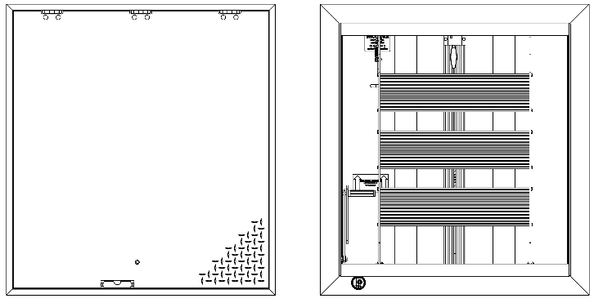
OPEN IN THIS POSITION
DO NOT OPEN IN THIS POSITION
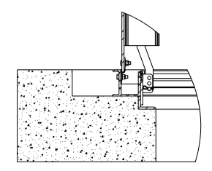
Cast-In Place Installation
Figure 1
H20 DOOR
SUPPORT SHELF

Note: All H20 off-street, infrequent vehicular traffic load rated floor doors must be installed with sufficient angle shelf support. Each door is manufactured with a support shelf as shown in Figure 1. It is the responsibility of the site structural engineer to determine medium type and depth of support needed for H20 loading.

Installation
- Set the frame in the opening
  - Secure the floor door into the desired area with welding, bolting or other anchorage, making sure not to interfere with the operation of the hatch.
- Square the frame
  - It is vital that the frame remains square during the concrete pour.
- Protect exposed aluminum from cement
  - To ensure a good quality installation and prevent staining, alkaline building materials such as cement should be removed quickly from aluminum surfaces.
- Pour cement
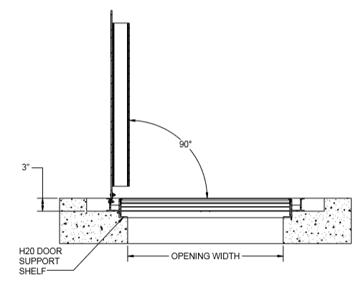
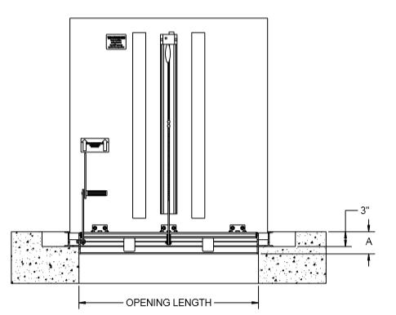
  - Pour cement to the top edge of the frame, leveling to finish flush with the top flange of the floor door. Allow to cure for seven days prior to opening the floor door. Opening the unit prior may crack the concrete.
  - After the seven days allowed for concrete curing, open the door(s) and inspect the unit for excess concrete that may have seeped or fallen into the hinges, or latch. (The doors will be heavy until the springs are engaged; opening will require two people.) It is important to note that springs will be disengaged on doors with more than one spring. Remove any concrete to ensure smooth operation.
- Engage Springs
Note: Doors with two or more springs per door will be shipped with the springs loose within the housing. These springs must be secured in place before operating the door.
  - Manually open the door to the 90-degree position. The hold open arm (HOA), will automatically hold the door open.
  - While in the 90-degree position the spring should settle on the plate at the bottom of the housing.
  - Slide the top spring plate (Figure 2) down until it touches the top of the spring. Using a 1/2-inch wrench tighten the two hex head screws.
Top Spring Plate
Hex Head Screws
  - Disengage the hold open arm to test the closing and opening operation. The door should slowly begin to close requiring assistance to fully shut.
Figure 2
- Adjust Spring (optional)
Note: Spring position is factory set. Adjust only if field conditions require more or less spring force.
  - Open the door to the 90-degree position, the HOA will automatically hold the door open.
  - The spring link bracket (Figure 3) allows spring tension adjustment by changing the position of the cotter pin link connection.
Figure 3
  - The lowest position provides the most spring force.
  - First, disengage the spring by loosening the two hex head screws at the top of the spring (Figure 2).
  - Remove the cotter pin and move the spring link into the desired position. Replace the cotter pin and re-tighten the hex head screws.
  - Disengage the hold open are to test the closing and opening operation. The door should slowly begin to close requiring assistance to fully shut.

Installation

Floor doors are designed and built for years of dependable access. All floor doors come standard with stainless steel hardware components. The basic components for door operation include turn handle latches, compression springs, stainless steel hinges and a locking hold open arm as detailed:

Operation
- Latch: 316 stainless steel slam latch with interior rotating handle, and exterior L-handle key
- Spring: Compression springs to ensure ease of opening and closing during use.
- Hinge: Stainless Steel hinges
- Hold Open Arm: Locking hold open arm automatically engages and locks when the door fully opens. The hold open arm must be engaged in the locked position to ensure that the door does not close unintentionally. Pull the red vinyl grip handle to unlock and safely close the door.
Opening Fully Installed Door
To open the floor door cover, use the slam latch L-handle key and rotate the slam latch. The cover will un-latch and the spring will begin to lift the door. Use the lift handles to fully pull open the door. The hold open arm engages and locks the cover in the 90-degree open position
Closing Fully Installed Door
To close the floor door cover, push down. Slam the door slightly to ensure proper latch engagement.

- Floor doors should be manually operated at minimum twice per year to check performance.

Maintenance
- Lubricate moving parts such as hinges, and latches with a food grade grease or silicone spray lube as required to maintain a smooth opening and closing of the door. Do not over grease. Do not use regular lubricating oil as it can attract dust and grit.
- Non-moving parts should be cleaned with a mild soap or dishwashing detergent and water solution.
- Gaskets should be cleaned with a clean, damp, lint-free cloth. Do not apply mineral oils, vinyl dressings, or other lubricants to the gasket as they may cause the gasket to break down over time.
- If floor doors are installed in corrosive environments such as environments exposed to saltwater or hydrogen chloride, the stainless-steel hardware must be coated with a custom finish and the springs should be lubricated on a strict three to six-month schedule.

Parts List
# | Part Number | Description
1 | FD-KIT-KEY18 | Latch Key
2 | FD-KIT-SLAMLATCH | Slam Latch
3 | FD-KIT-HINGE | Hinge
4 | FD-KIT-SPRING40-H20-O | Spring and Spring Link
5 | FD-KIT-SPRING80-H20-O | Spring and Spring Link
6 | FD-KIT-HOA | Hold Open Arm
7 | FD-KIT-PLUG | Latch Plug
8 | FD-KIT-SPFRAMEMOUNT18-D | Frame Mount Spring
9 | FD-KIT-GASKET18 | Gasket
 | FD-KIT-LIFTHANDLE | Lift Handle

Nystrom warrants all Floor Door Products to be free from manufacturing defects in materials, factory finishes and workmanship from the date of shipment for a period of:

Standard Warranty
5 Years
Should a product fail to function in normal use within this period, Nystrom shall furnish a replacement or new part at Nystrom’s discretion.
Failure to use product in methods consistent with Nystrom product manuals shall relieve Nystrom of any liability.
Our liability under this warranty excludes installation or removal costs involved in the product replacement and excludes any responsibility for incidental or consequential damage of any nature.

Factory Assistance
Nystrom engineers and manufactures floor door products for worldwide customers. Recognized as an industry leader, Nystrom has been relied upon by building and construction professions for over 70 years and we pride ourselves in offering exceptional technical support.
Please do not return any product before discussing your application problem with a Nystrom representative. All floor door products are custom made to order and are non-returnable.
Your Nystrom representative is eager to help you. Please feel free to call your representative or contact Nystrom to discuss your application.
Nystrom
9300 73rd Avenue North
Minneapolis, MN 55428

Phone: 800.547.2635
Fax: 800.317.8770
Email: info@nystrom.com

