Model(s): EJ QTT, EJ QTG
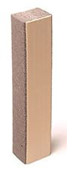
Preparation
- Locate the packing slip(s) and shop drawings.
- Verify that all products listed on the packing slip are included in the package.
- Check the products for damage. If products are damaged, report a freight claim immediately and leave the products in their packaging. If you sign for products without reporting damage you waive your right to a freight claim and will be responsible for their replacement cost.
- Read the instructions thoroughly before beginning installation.

Tools List
- Tape Measure
- Serrated Edge Knives
- Rigid Plastic Spatula or Plastic Trowel
- Spray Bottle Filled with Water
Pre-Installation
- Ensure joint faces are parallel and have sufficient depth to receive the full depth of the size(s) of QTT & QTG product being installed plus at least 1/4 inch (6mm).
- Wipe joint faces with lint-free rags dipped in solvent or other agent suitable for use on the substrates in question to ensure joint sides are free of dust, previous sealant, oils, grease, etc.
A
A
Installation
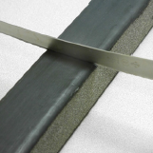
- Size and Adjust Lengths
  - Measure the widths of the opening and match to appropriately sized seal.
  - Measure the length of openings to receive seal. Using a bread-knife, or finely serrated knife, cut the seal to the appropriate length plus 1/2 inch. Slightly wet knife with water to facilitate cutting.
- Insert and Adjust Lengths into Gap
  - Starting at the bottom of the gap, insert the length of seal.
  - Hand compress as needed to ease the installation.
  - Work evenly up the length to obtain a consistent insertion
TIP: Lightly wet the sides of the seal which comes into contact with the wall or window with water to facilitate the insertion.
 | 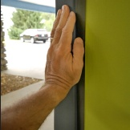 | 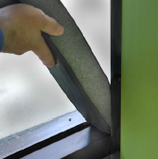

- Recess Seal
  - When properly installed the face of the seal should be recessed 1/4 inch from the outer edge of the mullion or wall.
  - With a plastic spatula or trowel, turn in the edges of the silicone faces so that they remain snug and do not allow for the foam to be exposed.
  - Seal will expand and be held in place by the backpressure of the foam.
Operation
Expansion joints are designed and built for years of dependable service.
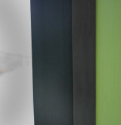
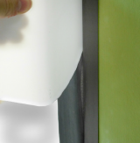
Maintenance
- Expansion Joints should be cleaned routinely.
- Exposed surfaces can be cleaned with a mild water-based cleaning solution. Wipe clean with a sponge or soft cloth.
- If any questions arise during the operation or maintenance of the products, please feel free to call our toll-free number for assistance, 1-800-547-2635 for technical support.

