December 28, 2017

RE: Smoke Vent Safety Railing Product Change Notice
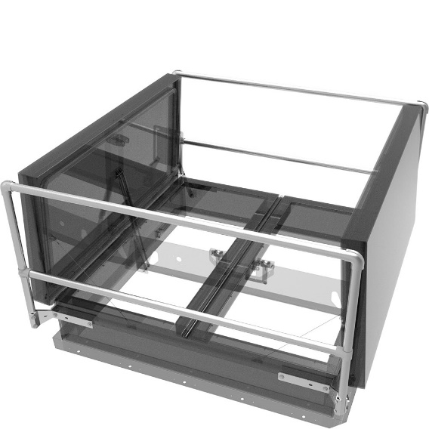

Nystrom announces the release of our updated Smoke Vent Safety Railings in aluminum.

Additions to the design:
  - New Aluminum rail and gate construction
  - Light weight design allows for easier and faster installation
  - Meets OSHA 29 CFR 1910.23, 1910.502, and 1926.501
  - Fits all brands of roof hatches that have a counterflash
  - Powder coat finish options available, including safety yellow
  - Still provides a non-penetrating attachment to the hatch via the counterflash
  - 5 year warranty
Specifications:
  - Rails / Posts – Aluminum pipe, 1-1/4 inch (31 mm) ID (1.66 inch OD) Schedule 40, 6061 T6 alloy
  - Fittings – Aluminum alloy 5052-H32
  - Mounting brackets – 3/16 inch steel, zinc plated
  - Hardware – Hex head bolts 3/8 inch – 16 by 34 inch zinc plated steel

4-SIDED MODEL | SIZE |  | 2-SIDED MODEL | SIZE
SRVA36X30NN | 36 X 30 |  | SRVA48XNNTB | 48
SRVA36X36NN | 36 X 36 |  | SRVA60XNNTN | 60
SRVA48X48NN | 48 X 48 |  | SRVA72XNNTN | 72
SRVA48X96NN | 48 X 96
SRVA60X96NN | 60 X 96
SRVA60X120NN | 60 X 120
SRVA60X144NN | 60 X 144
SRVA72X144NN | 72 X 144

The new aluminum smoke vent safety railing will begin shipping January 15, 2018. Please contact us at 1.800.547.2635 should you have any questions or concerns. We appreciate the opportunity to service you.

