Model(s): FD38SAM, FQ38SAM,
FT38SAM, FE38SAM, FV12SAM
Prepare for Installation
- Locate the packing slip(s) and shop drawings.
- Verify that all products listed on the packing slip are included in the package.
- Check the products for damage. If products are damaged, report a freight claim immediately and leave the products in their packaging. If you sign for products without reporting damage you waive your right to a freight claim and will be responsible for their replacement cost.
- Read the instructions thoroughly before beginning installation.
Install the Frame
A flat floor and accurately installed frames are critical to the overall performance of the grille.
- Verify that the floor is flat within 1/8 inch over 10 feet. Floor must be flat to prevent damage to the mat / grille. Utilize a self-leveling compound (provide by others) if necessary to ensure a level floor surface.
- Position the pre-cut and pre-mitered frame pieces on the floor as indicated on the shop drawings.
- Mark the fastening point locations on the frames. The required locations are indicated on the shop drawings. Otherwise, evenly space the fastening points at a maximum distance of 24 inches on all sides of the frame. Drill and countersink 1/4 inch diameter holes at the marked locations.
- Mark and drill 1/4 inch diameter holes in the floor for the anchors.
- Using the provided anchors, secure the frame to the floor.
Install the Grille
- Clean the recess thoroughly. Note that debris will cause irregularities in the recess that may cause the mat to rock or create a tripping hazard.
- Consult drawings to determine the correct locations of the grille sections.
- Set grilles into the recess.
- Save the installation and maintenance instructions and include them with the closeout documentation for the owner and maintenance personnel.
- See end of section for stainless steel grille installation.
Install the Mat
- Clean the recess thoroughly. Note that debris will cause irregularities in the recess that may cause the mat to rock or create a tripping hazard.
- Consult drawings to determine the correct locations of the mat sections. Mats provided in multiple sections in the traffic direction will include an additional hinge for combining the sections.
- Unroll the mat inside the frame. Push the mat tightly up against one side of the frame. Trim the attached vinyl filler to ensure a tight fit in the recess.
- Save the installation and maintenance instructions and include them with the information that will be passed on to the owner or maintenance personnel.
Installation for a stainless-steel grille only

- Clean the recess thoroughly. Note that debris will cause irregularities in the recess that will in turn cause the grille to rock or create a tripping hazard.
- Refer to the shop drawings and the marks on the sections to determine the correct location of each section. Note that the grille sections are not interchangeable.
- Refer to the following hold-down illustration below while assembling hold-downs. Place the stainless-steel screws in all hold-downs on the grille sections. Use the plastic washers provided to hold the screws in the lock-downs before putting the grilles into the recess. DO NOT attempt to put the lock-down screws in by prying apart the surface wires and installing from the top of the grille. This will cause irreversible damage that is not covered by the warranty.

Illustration 1: Hold-downs must be assembled as illustrated.
- Install the hold-down clips in the grille. They should be placed around the perimeter of each section and spaced at a maximum distance of 18 inches apart throughout each section and over the entire grating.
- To install the clips, place the clip in the frame at an angle and use a pry bar to insert the clip into the frame (See Figure 1). Press/Tap the clip into place using a flat head screwdriver so the fingers of the clips snap into the spaced between the surface wires. (See Figure 2)

Figure 1 | Figure 2
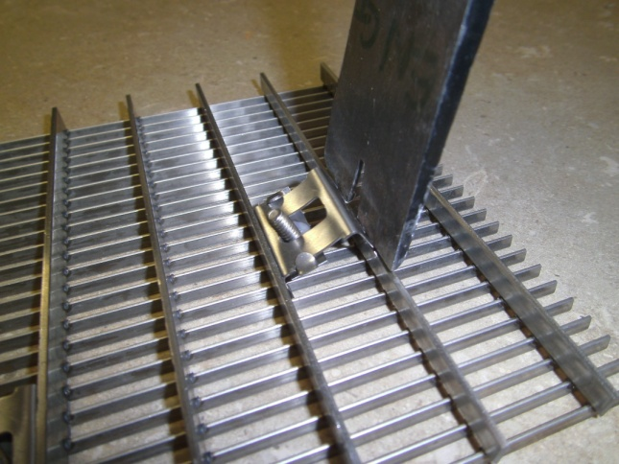 | 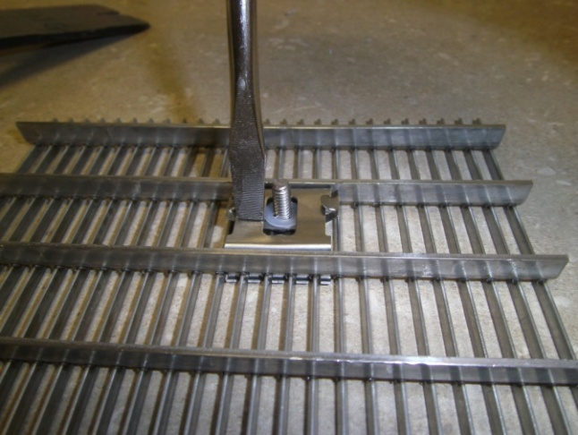
- Place the grille sections in position within the recess. Refer to the shop drawings for the proper location of the sections. Mark the locations of lock-down holes in the concrete pit.
- Remove the grating and set aside. Drill 3/8 inches diameter by 5/8 inches deep holes into concrete at the marked locations for anchors provided.
- Clear the hole of all debris.
- Insert the threaded cone end of the anchor into the hole. Insert the provided setting tool into the anchor and hit the setting tool with a hammer until the anchor is set.
- Set the grille sections back into the recess and start threading all hold-down screws in the embedded anchors. Adjust the grilles to create an even clearance around the edges and tighten all screws. Do not over-tighten the screws. There should still be some play in the hold-down straps.
- Save the installation and maintenance instructions and include them with the closeout documentation for the owner and maintenance personnel.
maintenance
Continued maintenance is critical to the long-term safety and performance of the mat / grille. Remove the mat / grille and clean the recess periodically to prevent the surface from becoming uneven. Debris build up within the recess could lead to deflection in the grille and may possibly cause tripping hazards.
The type and schedule of maintenance of your grille or mat will depend upon location and amount of traffic. See the outline below for cleaning instructions for the variety of tread insert materials.
Aluminum Abrasive
- Clean the vinyl abrasive treads with a vacuum or broom.
- Do not use any hydrocarbon solvents such as kerosene, paint thinner or acetone to clean aluminum abrasive treads. These types of solvents will damage the treads
Brush
- Clean the brush treads with a vacuum.
- Do not use petroleum-based products to clean brush bristles. These types of solvents will damage or fade the treads.
EcoTread
- Use a mild detergent and water with a soft bristle brush or microfiber mop.
- Do not use petroleum-based products to clean recycled rubber. These types of solvents will damage or fade the treads.
Premium Carpet, EnvIRONtread® II
- A good heavy-duty vacuum cleaner with a rotating brush is the most effective way to routinely clean the carpet in your entrance grille or mat. By vibrating the fibers, this type of vacuum not only cleans the surface of the carpet, but also removes soil that is imbedded into the pile. The rotating brush aids in keeping the pile upright for longer lasting beauty.
- The heaviest traffic areas should be vacuumed daily and the light traffic areas as infrequently as weekly.
- Carpet should be deep cleaned with a hot water extraction cleaner once per month or when vacuuming will no longer remove the soil. This may be monthly, quarterly, or longer, depending upon soil and traffic conditions.
- Inspect the grille or mat regularly for spots and stains, to reduce the possibility of them becoming permanent.
- Removing Spots
  - If the spot is semi-solid, scrape with a spoon or spatula and then blot with a damp sponge. Work from the edge of the spot to the center. This will keep the stain from spreading. If this procedure does not work, use a spot remover.
  - We recommend a dry system because it reduces solid build-up won’t leave floors wet and slippery, and there is no risk in damaging the carpet from dye bleeding. For most spills such as coffee, tea, pet stains, etc., a dry soil extractor works best.
  - Wet cleaning methods, including aerosols, foams, hot water extraction, or shampoo will work, but sometimes they leave sticky detergent residue that will accelerate soil build-up.
  - For oily stains such as tar, grease, paint, etc., a non-flammable dry cleaning solvent works best. Be extremely careful when using dry cleaning solvent. Take care to check for color fastness before cleaning the entire surface. Put a few drops of stain remover in an inconspicuous area and press the area with a clean cloth for ten seconds. If the color fades or changes, discontinue use.

Rubber
- Use a mild detergent and water to damp mop the rubber treads. To remove caked on mud, use a stiff brush.
- Do not use petroleum-based products to clean rubber. These types of solvents will damage or fade the treads.
Rugged Scrub®
- The most effective way to clean the treads is with a garden hose or high-pressure washer, as necessary. The treads can withstand pressure of up to 1,000 pounds per square inch. A good heavy-duty vacuum cleaner with a rotating brush will remove most dirt from your Rugged Scrub® treads during routine daily cleaning.
- Do not use petroleum-based products to clean Rugged Scrub. These types of solvents will damage or dissolve the treads.
Serrated Aluminum Mats and Grilles
- Clean the treads with a vacuum or broom first, and then mop the treads with standard floor cleaner.
Stainless Steel Grilles
- Surface wires can be cleaned with a non-ferrous cleaner such as 3M’s Scotch Brite™
- Do not use steel wool or abrasive pads. The steel in these products will embed in the wires and subsequently rust.
Vinyl Abrasive Tread
- Clean the vinyl abrasive treads with a vacuum or broom.
- Do not use any hydrocarbon solvents such as kerosene, paint thinner or acetone to clean vinyl abrasive treads. These types of solvents will damage or fade the treads.
Vinyl Tread
- Use a mild detergent and water to damp mop the vinyl treads. To remove caked on mud, use a stiff brush.
- Do not use petroleum-based products to clean vinyl. These types of solvents will damage or fade the treads.
Follow the tread maintenance instructions to ensure the long life of the grille tread. Contact Nystrom for information on replacing damaged treads.

